A Multispectral Texture-Feature Machine Learning Framework for Cotton Bacterial Blight Severity Classification
Hafiz Muhammad Ijaz¹, Muhammad Asadullah^{1,*}
¹ Department of Information Technology. The Islamia University of Bahawalpur Pakistan.
Authors E-Mail: Ijazhafiz7@gmail.com, muhammad.asadullah@iub.edu.pk
Abstract

Bacterial blight is caused by X. campestris PV. Malvacearum is one of the most destructive disease of cotton (Gossypium spp.) under severe field conditions, and loss up to 30% of the crop occurs under such conditions and poses a threat to cotton economy of the cotton producing countries including Pakistan. Traditional visual inspection diagnostic methods are slow, subjective, and inaccurate at detecting early in-factions, thus promoting automated image-based diagnostic methods. This study introduces a novel feature-based machine vision technique that integrates texture, histogram, binary and rotation-scale-translation (RST) invariant features with machine learning classifiers to categorize bacterial blight into Low, Normal and High infection classes in cotton leaves. The data set consists of 900 cotton leaf images, which were pre-processed by resizing, grayscale conversion and contrast enhancement, with 300 images of each type. Fifty-five texture, histogram, binary, and RST features were computed across multiple region-of-interest (ROI) sizes using CVIPtools, and Correlation-based Feature Selection (CFS) reduced this set to 20 optimal features. These features were used to train and evaluate twelve machine learning classifiers and four deep learning models in Weka environment using 10-fold cross-validation. The instance-based Lazy.IB1 classifier accomplished the maximum weighted-average accuracy of 93.33%, with a recall of 93.33% and an F-measure of 0.933 on the 16×16 ROI feature set, outperforming Lazy.IBK (93.22%), Random Tree (93.00%), Random Committee (92.93%), Random Forest (92.85%), and all deep learning models evaluated. The findings show that a compact, interpretable, feature-based pipeline can match or exceed considerably more computationally expensive deep learning approaches, offering a practical, low-cost decision-support tool for precision cotton agriculture.

Keywords: bacterial blight, cotton leaf disease, machine vision, texture features, GLCM, feature selection, machine learning,

1. Introduction
Cotton (Gossypium spp.) is one of the world's most economically significant fiber crops, cultivated in nearly 100 countries and covering about 2.5% of global arable land (Vitale et al., 2024). It under-pins the livelihoods of hundreds of millions of farmers and allied-industry workers, and in Pakistan it remains a cornerstone of the agricultural economy, contributing substantially to export revenue, GDP, and rural employment (Abdu et al., 2021; Kashif et al., 2022; MN et al., 2022). Cotton is still facing the threat of fungal, viral and bacterial diseases, which cause 10-30% (up to 60-74%) losses per year due to their diseases and pest pressure (Akhtar et al., 2024).
Among these, bacterial blight, caused by Xanthomonas campestris PV. Malvacearum (Xam), is one of the most economically damaging. It spreads rapidly under warm, humid conditions, producing angular, water-soaked lesions that progress to necrotic spots, leaf blackening, boll rot, and premature defoliation (Kemerait et al., 2017; Singh et al., 2007; Wheeler, 2018). Field surveys report incidence ranging from roughly 3.5-16.0% percent disease incidence (PDI) in winter plantings to up to 13.8% PDI in summer plantings, with yield reductions of 12%, 20%, and 33% depending on the growth stage at infection, and sowing date has itself been shown to shift disease incidence and consequent yield loss (Borkar et al., 2024; Mohammed et al., 2003; Sowmiya et al., 2022). Because bacterial blight can be confused with other foliar disorders such as leaf spot or cotton leaf curl virus, accurate diagnosis at an early stage enables the implementation of targeted disease-management measures. (Ahmad et al., 2024; Anwar, Rahim Kolachi, et al., 2023).
Bacterial blight and other cotton leaf diseases are traditionally diagnosed through manual field in-spection. Skilled inspectors can achieve reasonable accuracy, but studies report that horticultural ex-perts using conventional visual methods achieve only around 88% accuracy, with quality depending heavily on experience, field size, and infection stage at observation (Mehmood et al., 2023); Comparable severity-assessment challenges have also been documented for bacterial blight of rice (Arshad et al., 2020). Manual scouting is time-consuming and difficult to scale, particularly where extension services are limited, creating strong motivation for automated, image-based detection systems (Ku-mar Gudela et al., 2023).
Over the past decade, computer vision, machine learning (ML), and deep learning (DL) have enabled a wide range of automated plant disease recognition systems. Convolutional neural network (CNN) architectures have been widely adopted for cotton leaf disease classification, with reported accuracies from the high 80s to above 98% depending on the dataset and disease category (Akbar et al., 2024; Anwar, Soomro, et al., 2023; Baljon, 2023; Islam et al., 2023; Shao et al., 2023; Shao et al., 2024). These methods are frequently very precise, but they often depend on a large, well-annotated data set, and yield models that are hard to interpret and difficult to apply in resource-limited agricultural contexts. A different line of research, however, has focused on feature-based machine vision pipelines, where handcrafted texture, statistical and shape descriptors are extracted and fed to a standard classifiers. While not as well studied for cotton bacterial blight itself, these methods have proven to be effective in similar image classification tasks such as variety classification of rice and classification of brain tumors and are relatively computationally inexpensive (Amin et al., 2022; Aslam et al., 2025; Khalid et al., 2025).
Only a limited number of studies have conducted a systematic comparison between a wide range of feature-based machine learning classifiers and deep learning models for the same multiclass bacterial blight severity classification problem. In particular, the combined use of texture, histogram, binary, and rotation-scale-translation (RST)-invariant features extracted from regions of interest (ROIs) at different resolutions remains insufficiently explored. To address this research gap, the present study develops a feature-based framework for classifying bacterial blight severity into three categories: Low, Normal, and High. The goals of this study include: (i) developing an image acquisition and pre-processing pipeline for identifying the level of severity of different types of diseases in cotton; (ii) extracting the texture, histogram, binary and RST-invariant features from the selected regions of interests; (iii) selecting the most relevant features through correlation-based feature selection; (iv) evaluating and comparing the performance of twelve machine learning classifiers along with four deep learning methods based on the extracted features; and (v) comparison of the proposed framework with previously developed cotton disease recognizers from literature. The main contributions of this research include:
•Image processing pipeline: Image acquisition and pre-processing workflow for multiclass classification of the bacterial blight severity is developed. The three major components of this workflow are of great importance. These are: Image resizing, grayscale conversion, and contrast enhancement. In total, fifty five features have been extracted, which include first order histogram statistics, second order GLCM/ Haralick texture features, binary shape features, and RST-invariant features. Five different levels of ROI resolution are used to test the visual characteristics of disease.• Application of Correlation-based Feature Selection (CFS) to reduce the 55-feature set to 20 opti-mal, non-redundant, discriminative features.
• A head-to-head evaluation of twelve machine learning classifiers and four deep learning models on the same feature-selected dataset using 10-fold cross-validation.
• A quantitative benchmark of the proposed framework against previously published cotton leaf dis-ease detection studies.

The rest of this paper is structured as follows. Section 2 discusses previous research on cotton leaf disease detection. Section 3 explains the methodology proposed in this study. Section 4 reports the experimental findings and compares the proposed approach with existing benchmarks. Comparison. Section 5 concludes the paper and outlines future research directions.

2. Literature Review
This section reviews prior research organized into four themes: (i) the agronomic and economic significance of bacterial blight in cotton; (ii) deep learning approaches for cotton leaf disease detection; (iii) feature-based and texture-analysis approaches; and (iv) multispectral and UAV-based detection approaches.

2.1 Bacterial Blight in Cotton: Agronomic and Economic Context
Bacterial blight of cotton, caused by Xanthomonas campestris PV. Malvacearum, was first described more than a century ago and remains one of the most widespread bacterial diseases of cultivated cotton (Singh et al., 2007). Various symptoms of bacterial blight were described such as angular lesions on leaves, darkening of veins, blight of young seedlings, and boll rot. These symptoms are closely related to environmental conditions like humidity and rainfall, and the spread of pathogens via wind. Agricultural practices (e.g. sowing time) can affect disease incidence and losses in crop yield in addition to weather. (Wheeler, 2018; Mohammed et al., 2003). The cultural practices traditionally used for control of bacterial blight remain the mainstay for its control. Crop rotation, resistant cultivars, and good field sanitation practices were also cited by Kemerait et al. as being important for minimizing disease development, and again stress the importance of timely and reliable diagnosis of disease. (Kemerait et al., 2017). Variations in disease incidence have also been found through field investigations, conducted in different seasons of growth. Sowmiya et al., for instance, evaluated bacterial blight incidence with respect to different cropping conditions, Borkar et al., studied variability between pathogen pathotypes and their impact on cultivar resistance. (Sowmiya et al., 2022; Borkar et al., 2024). Some of the same problems of precise disease grading have been noted in investigations of bacterial blight of rice grown in Punjab, Pakistan. (Arshad et al., 2020). Though there have been efforts to get better and resistant varieties, bacterial blight and other biotic stresses like cotton leaf curl virus are important factors in reducing the productivity of cotton in Pakistan. (Abdu et al., 2021; Kashif et al., 2022; MN et al., 2022). Akhtar et al. also linked the disease-induced yield losses to broader issues impacting competitiveness of Pakistan's Cotton industry. (Akhtar et al., 2024). In general, these studies have illustrated the high losses in cotton production caused by bacterial blight and the difficulties in making a correct conventional visual determination of the disease, especially when symptoms are similar to other foliar diseases. These restrictions underscore the importance of a disease detection and severity assessment method that is reliable and automated, using images.
2.2 Deep Learning Approaches for Cotton Leaf Disease Detection
In recent years, automated classification of cotton leaf diseases has received more attention due to the use of convolutional neural networks (CNNs) and other deep learning architectures. Anwar et al. proposed a CNN-based classification model with fuzzy k-means clustering technique for separating cotton leaf curl virus from bacterial blight. Their proposed method achieved classification accuracy of up to 93.33%, demonstrating the potential of deep learning techniques for automated cotton disease recognition (Anwar, Rahim Kolachi, et al., 2023). Kumar Gudela et al. evaluated a MobileNet snapshot ensemble with a vision transformer, reporting accuracies around 93% using SVM feature combinations and up to 93.22% using k-nearest neighbor classifiers (Kumar Gudela et al., 2023). Islam et al. fine-tuned VGG16, VGG19, Inception V3, and Xception for cotton leaf disease classification and deployed the best model (Xception, 98.70% accuracy) in a web-based diagnostic application (Islam et al., 2023). Shao et al. introduced a bilinear coordinate attention module, reporting 96.61% accuracy (Shao et al., 2023), while a separate study by Shao et al. proposed an attention-based CNN for natural field conditions, reporting 96.3% on a custom dataset and up to 98.6% on public benchmarks (Shao et al., 2024). Akbar et al. addressed class imbalance using GAN-based augmentation with VGG16, Inception V3, and ResNet50 backbones, reporting ~95% accuracy and an F1-score of 0.98 on a seven-class dataset (Akbar et al., 2024). Anwar et al. benchmarked six pretrained architectures and reported a maximum accuracy of 96% for DenseNet169 and ResNet50V2 (2023), while Aslam et al. proposed a synergistic multi-CNN ensemble (Aslam et al., 2025) and Khalid et al. developed an image-processing pipeline for multiple cotton diseases (Khalid et al., 2025). Amin et al. contributed an explainable network combining VGG-16 feature extraction with fully convolutional layers, reporting 99.99% accuracy on two public datasets and addressing the interpretability limitations that commonly hinder deep learning implementation in agriculture (Amin et al., 2022). Suleman Memon et al. reported accuracy as high as 98.53% for a Meta deep learning model on an augmented dataset of 2,385 leaf images (Suleman Memon et al., 2022). A related line of work has applied recurrent architectures, including LSTM and Bi-LSTM networks, to classify Xanthomonas-caused bacterial blight in other crops such as bean, underscoring the broader applicability of sequence-based deep models to bacterial plant pathogens (Kursun et al., 2024). The past few years, the automated classification of cotton leaf diseases has begun to be the focus of attention of researchers with a growing focus on convolutional neural networks (CNNs) and other deep learning architectures. For instance, Anwar et al. developed a CNN based approach that is combined with fuzzy k-means clustering to differentiate between cotton leaf curl virus and bacterial blight. Their idea yielded superior classification accuracy of up to 93.33%, showing the capability of deep learning methods in automated recognition of cotton disease. (Anwar, Rahim Kolachi, et al., 2023).
2.3 Feature-Based and Texture-Analysis Approaches

An alternative, complementary line of research has focused on handcrafted feature extraction com-bined with conventional machine learning classifiers. Arivazhagan et al. demonstrated that texture features alone can effectively detect unhealthy leaf regions and classify plant diseases, an early foundation for the texture-based classification approach used in this study (Arivazhagan et al., 2013). Texture analysis based on the Gray-Level Co-occurrence Matrix (GLCM) and the associated Haralick parameters, including angular second moment, contrast, correlation, and homogeneity, re-mains one of the most widely used approaches for quantifying spatial pixel-intensity relationships (Chandra Raju et al., 2022); Meena et al. combined GLCM texture features with a CNN specifically for cotton disease identification (Meena et al., 2024), and Kotian applied machine learning classifiers directly to cotton leaf disease detection (Kotian, 2022). Qadri et al. applied a machine vision approach combining statistical texture features with conventional classifiers to classify rice varieties (Qadri et al., 2021), and related work by the same group applied multispectral and texture data to land-cover and land-use classification (Qadri et al., 2016). A separate study by the same research group applied hybrid optimized multi-feature analysis to brain tumor classification from MRI data, again combining texture, histogram, and shape features with machine learning classifiers (Nawaz et al., 2022; Nawaz et al., 2024; Sachdeva et al., 2013). Patil and Burkpalli specifically evaluated cot-ton leaf image classification using multiple machine learning algorithms within the Weka environment, the same workbench used in this study (Patil & Burkpalli, 2021). Because the number of candidate texture and statistical features can be large, feature selection plays a critical role in reducing dimensionality and overfitting risk; Jovic et al. reviewed filter, wrapper, and embedded feature-selection methods (Jović et al., 2015), Lutu and Andries proposed a decision rule-based method for feature selection in predictive data mining (Lutu & Andries, 2010), and Zebari et al. reviewed di-mensionality-reduction techniques more broadly, including correlation-based and principal-component-based methods (Zebari et al., 2020). Tripathy and Maktedar reviewed the use of computer vision techniques for evaluating the quality of fruits and vegetables. Their findings indicated that traditional feature-based approaches can still provide competitive results compared with deep learning methods, particularly in situations where only a limited amount of labeled image data is available (Tripathy & Maktedar, 2020). Foundational architectures such as the deep residual network of He et al. have substantially advanced general image classification (He et al., 2016), but their reliance on large-scale training data and compute motivates continued interest in lightweight, interpretable, feature-based alternatives for specialized agricultural applications such as the one addressed here.

2.4 Multispectral and UAV-Based Detection Approaches

A separate strand of research has explored multispectral and unmanned aerial vehicle (UAV)-based imaging for cotton disease detection at the canopy or field scale. Wang et al. used ground-framed canopy photography combined with multispectral UAV imagery to identify cotton blight symptoms, finding that multispectral indices improved discrimination between healthy and diseased canopy re-gions relative to standard RGB imagery (Wang et al., 2023). Xavier et al. applied multispectral, mul-tiscale UAV imagery to classify Ramularia leaf blight severity in cotton, showing that canopy-scale multispectral data can capture severity gradients difficult to observe with ground-level RGB pho-tography (Xavier et al., 2019), while Prasad et al. combined GAN-based augmentation with UAV imagery in a two-step machine learning pipeline for crop disease detection more broadly (Prasad et al., 2022). These studies suggest that multispectral information, at either leaf or canopy scale, carries diagnostically relevant signal beyond the visible spectrum, motivating the multispectral feature ex-traction used in the framework proposed here.

2.5 Summary of Reviewed Studies
Table 1 summarizes the methodology and reported accuracy of the principal cotton disease detection studies reviewed above, providing a reference point against which the proposed framework is benchmarked in Section 4.4 (Table 10).
Table 1
Summary of Reviewed Cotton Leaf Disease Detection Studies
Reference | Approach | Classification Target | Reported Accuracy
Anwar, Rahim Kolachi, et al. (2023) | CNN + fuzzy k-means clustering | Bacterial blight / leaf curl virus | 93.33%
Kumar Gudela et al. (2023) | MobileNet ensemble / SVM / KNN | Multiclass cotton crop disease | 93.00-93.22%
Islam et al. (2023) | Fine-tuned transfer learning (VGG16/19, InceptionV3, Xception) | CLCuV, bacterial blight, healthy | 98.70%
M. Shao et al. (2023) | Bilinear coordinate attention CNN | Cotton leaf disease (natural environment) | 96.61%
Y. Shao et al. (2024) | Attention-based CNN (field conditions) | Cotton disease (natural environment) | 96.30-98.60%
Akbar et al. (2024) | GAN augmentation + VGG16/InceptionV3/ResNet50 | Seven-class cotton lesion dataset | ~95.00%
Anwar, Soomro, et al. (2023) | Deep transfer learning benchmark (6 CNNs) | Bacterial blight, curl virus, healthy | Up to 96.00%
Amin et al. (2022) | Explainable VGG-16 based CNN | Cotton leaf disease classification | 99.99%
Wang et al. (2023) | Multispectral UAV canopy imagery | Cotton blight (canopy scale) | Qualitative discrimination
Xavier et al. (2019) | Multispectral, multiscale UAV imagery | Ramularia leaf blight severity levels | Severity-graded classification
Suleman Memon et al. (2022) | Meta deep learning model | Healthy vs. diseased cotton leaves | 98.53%
Several patterns emerge from Table 1. Studies addressing binary or few-class classification on curated, controlled-condition datasets tend to report the highest accuracies. Most target categorical disease-type or healthy-versus-diseased classification rather than the finer-grained severity grading (Low, Normal, and High) addressed here, which is important when interpreting the comparative accuracy figures in Section 4.4, since severity grading among visually similar infection stages is generally a harder classification problem than distinguishing visually distinct disease types.

2.6 Research Gap
Taken together, the reviewed literature shows strong interest in both deep learning and feature-based approaches for cotton leaf disease detection, and growing interest in multispectral and UAV-based imaging. However, few studies have compared a broad panel of conventional machine learning classifiers against deep learning models on a common multiclass severity task using texture, histogram, binary, and RST invariant features at multiple ROI resolutions, and most target binary healthy-versus-diseased classification rather than severity grading. This study addresses that gap by assessing twelve machine learning classifiers and four deep learning models on a correlation-based feature-selected subset of these features, and by benchmarking the framework against published cotton disease detection studies.

3. Material and Methods

3.1 Proposed Methodology Overview
The proposed framework follows a standard machine-vision classification pipeline comprising six stages: (i) image dataset acquisition, (ii) image pre-processing, (iii) region-of-interest (ROI) segmentation, (iv), texture histogram, binary, and RST feature extraction, (v) correlation-based feature selection, and (vi) Classification using machine learning and deep learning algorithms. Each stage described below, and complete pipeline is summarized in Figure 1 and formalized as Algorithm 1 in Section 3.10.
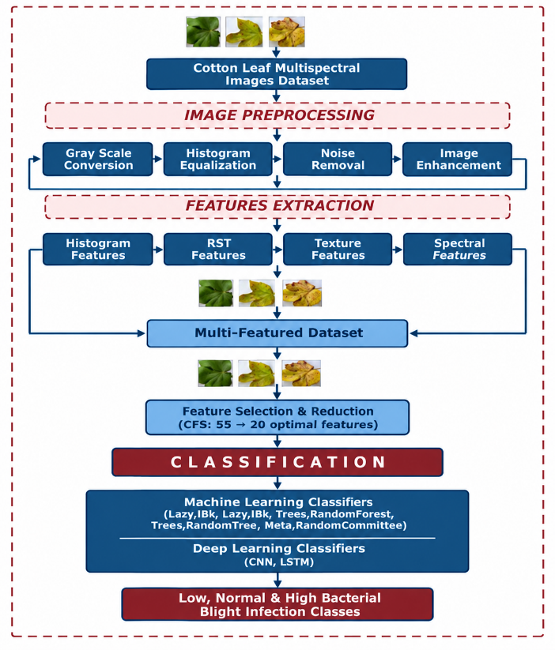
Figure 1
Block Diagram of the Proposed Bacterial Blight Detection and Classification Framework

3.2 Dataset Acquisition and Sampling
Cotton leaf images were collected across three bacterial blight infection severity categories: Low infection, where the affected leaf area is small and symptoms are early and mild; Normal infection, where a moderate, clearly visible portion of the leaf shows blight symptoms; and High infection, where extensive leaf area shows well-developed necrotic and water-soaked lesions. For multi class classification, a set of 900 cotton leaf images was used, where 300 images were selected to each infection category, giving a uniform class distribution. Images were captured under natural field lighting conditions to more closely represent practical agricultural field conditions. Each sample was manually checked before the image processing stage and put into its respective category. Table 2 shows the overall distribution and composition of the data.
Table 2
Composition of Cotton Leaf Image Datasets
Infection Category | Number of Images | Proportion of Dataset
Low Infection | 300 | 33.33%
Normal Infection | 300 | 33.33%
High Infection | 300 | 33.33%
Total | 900 | 100.00%
To prevent the possibility of bias in the training and testing of the classifiers, the dataset was intentionally balanced among the different classes. This balance is important to provide a fair representation of the accuracy and F-measure results presented in Section 4, than being skewed by an overrepresented class.
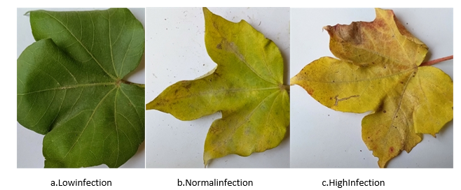
Figure 2
Representative Cotton Leaf Image Samples for the Three Infection Severity Categories Used in This Study: (A) Low Infection, (B) Normal Infection, (C) High Infection
In this study, cotton leaf images were captured with various leaf infection categories as shown in figure 2. Low Infection leaves have mostly uniform green colour; Normal Infection leaves display visible yellowing and scattered necrosis; and High Infection leaves are yellow to brown with distinct necrosis along the margins .These progressive visual and textural differences form the basis for the feature extraction described in Section 3.5.

3.3 Image Pre-Processing
Raw field images inherently vary in camera distance, illumination, and sensor noise, all of which can adversely affect feature extraction and classification. A three-stage pre-processing pipeline was therefore applied to every image.
3.3.1 Image Resizing.
Because source images varied in native resolution, every image was resized to a fixed 256 × 256 and16×16 pixels, ensuring a consistent aspect ratio and pixel count that is essential for extracting comparable ROI segments and reduces downstream computational cost.
3.3.2 Grayscale Conversion.
Color RGB images were converted to grayscale using CVIPtools, which computes a luminance-weighted transformation of red, green, and blue channels-a necessary pre-requisite for the statistical and co-occurrence-based texture features described in Section 3.5, since these descriptors operate on single-channel intensity values.
3.3.3 Image Enhancement.
Contrast enhancement and noise-reduction filters were applied after grayscale conversion to suppress background noise, improve lesion boundary visibility, and normalize brightness variation arising from differences in ambient field lighting.

3.4 Region-of-Interest (ROI) Segmentation

The purpose of this step is to separate out the infected part of the leaf from its background such that the feature extraction phase will concentrate only on those parts of the image that carry information related to the disease. In the present study, ROIs were produced at various resolutions of pixels so as to analyze the effect of size of ROI on the classification accuracy. Various resolutions used in the present study are from 16×16 to 256×256 pixels. Small ROIs give more weight-age to local texture variations and lesion patterns formed during the initial stages of the disease while large ROIs preserve more of the spatial context information which can represent the disease in the advanced stages.

3.5 Feature Extraction

The feature extraction stage is aimed at transforming the raw pixel information existing within the ROIs to numeric feature representations, which can then be used efficiently by machine learning algorithms for classification purposes. A total of 55 features spanning four categories, first-order histogram features, second-order (co-occurrence) texture features, binary features, and rotation-scale-translation (RST) invariant features - were computed for each ROI using CVIPtools.

3.5.1 First-Order Histogram Features
These describe the statistical distribution of pixel intensities within a region without regard to spatial arrangement, including mean, standard deviation, skewness, energy, and entropy of intensity histogram-computationally efficient measures that summarize overall brightness and contrast.
Let g denote a gray level, L the numbers of gray levels, and M the number of pixels in ROI. With N(g) the number of pixels having gray level g, the normalized histogram is P(g) = N(g) / M, and five first-order features are computed as:
$$μ=\sum_{g=0}^{L-1}{g} P\left(g\right)$$  Average gray-level intensity of the ROI. | (1)
$$σ=\sqrt{\sum_{g=0}^{L-1}{{\left(g-μ\right)}^{2}} P\left(g\right)}$$  Spread of pixel intensities around the mean (contrast). | (2)
$$Skew=\frac{1}{σ^{3}}\sum_{g=0}^{L-1}{{\left(g-μ\right)}^{3}} P\left(g\right)$$  Asymmetry of the intensity distribution about the mean. | (3)
$$E_{h}=\sum_{g=0}^{L-1}{{\left[P\left(g\right)\right]}^{2}}$$  Uniformity of the histogram; high when few gray levels dominate. | (4)
$$H_{h}=-\sum_{g=0}^{L-1}{P}\left(g\right) \log_{2}P\left(g\right)$$  Randomness (disorder) of the intensity distribution. | (5)

3.5.2 Second-Order (Co-Occurrence) Texture Features

These derived from Gray-Level Co-occurrence Matrix, which tabulates how often pairs of pixel in-tensities occur at a given spatial offset and orientation. From GLCM, the Haralick texture parameters were computed, including Angular Second Moment (Energy), which measures textural uniformity; Contrast, which quantifies local intensity variation between neighboring pixels; Correlation, which measures the linear dependency of gray levels between neighboring pixels; Homogeneity-ty (Inverse Difference Moment), which measures how closely the GLCM mass concentrates near its diagonal; Variance, Sum Average, Sum Variance, and Sum Entropy, which characterize dispersion and information content; Entropy, Difference Variance, and Difference Entropy, which further characterize randomness and local variability; and the Information Measures of Correlation I and II and the Maximum Correlation Coefficient, which capture higher-order statistical dependencies. These parameters have been successfully applied in medical and agricultural image classification, including brain tumor and rice variety classification (Chandra Raju et al. 2022; Nawaz et al. 2022; Nawaz et al. 2024; Qadri et al. 2021), and were selected here because they are sensitive to the subtle textural changes - lesion roughness, vein disruption - that accompany bacterial blight infection.

3.5.3 Binary and RST Invariant Features
Binary shape descriptors were extracted to characterize lesion morphology after thresholding, while rotation-scale-translation (RST) invariant features ensure that classification performance is not degraded by variation in leaf orientation, camera distance, or image scale at capture time-particularly important for field-deployed systems, where leaves are rarely photographed under standardized geometric conditions.
Let B(x, y) ∈ {0, 1} denote the binary image of an ROI with N_{x} columns and N_{y} rows obtained by thresholding, where B(x, y) = 1 marks object (lesion) pixels. The eight binary shape features (area, centroid, orientation, perimeter, Euler number, projections, thinness ratio, and aspect ratio) are defined as:
$$A=\sum_{x=0}^{N_{x}-1}{\sum_{y=0}^{N_{y}-1}{B}}\left(x,y\right)$$  Total number of object pixels in the ROI. | (6)
$$\overset{‾}{x}=\frac{1}{A}\sum_{x=0}^{N_{x}-1}{\sum_{y=0}^{N_{y}-1}{x}} B\left(x,y\right)$$  Mean column position of the object pixels (x-coordinate of the centroid). | (7)
$$\overset{‾}{y}=\frac{1}{A}\sum_{x=0}^{N_{x}-1}{\sum_{y=0}^{N_{y}-1}{y}} B\left(x,y\right)$$  Mean row position of the object pixels (y-coordinate of the centroid). | (8)
$$\begin{matrix}μ_{pq}= & \sum_{x=0}^{N_{x}-1}{\sum_{y=0}^{N_{y}-1}{{\left(x-\overset{‾}{x}\right)}^{p}}} \\ & ×{\left(y-\overset{‾}{y}\right)}^{q} B\left(x,y\right)\end{matrix}$$  Central moment | (9)
$$θ=\frac{1}{2}arctan\left(\frac{2μ_{11}}{μ_{20}-μ_{02}}\right)$$  Orientation | (10)
$$\begin{matrix}Per & =\left|\left\{\left(x,y\right):B\left(x,y\right)=1,\right.\right. \\ & \left.\left.∃ \left(x^{'},y^{'}\right)∈N_{4}\left(x,y\right), B\left(x^{'},y^{'}\right)=0\right\}\right|\end{matrix}$$  Number of object pixels lying on the region boundary. | (11)
$$E=N_{o}-N_{h}$$  Euler number | (12)
$$T=\frac{4πA}{{Per}^{2}}$$  Thinness ratio | (13)
$$AR=\frac{x_{max}-x_{min}+1}{y_{max}-y_{min}+1}$$  Ratio of the region's width to its height. | (14)
$${Pr}_{h}\left(y\right)=\sum_{x=0}^{N_{x}-1}{B}\left(x,y\right)$$  Horizontal projection | (15)
$${Pr}_{v}\left(x\right)=\sum_{y=0}^{N_{y}-1}{B}\left(x,y\right)$$  Vertical projection | (16)
Where N₄(x, y) is the set of 4-connected neighbours of pixel (x, y), N_{o} is the number of objects (connected components) in the region, and N_{h} is the number of holes. The second-order central moments μ₂₀, μ₀₂, and μ₁₁ describe the spread and elongation of the object and give its orientation θ, the angle of the major axis relative to the x-axis. The horizontal and vertical projections are sums of object pixels along each row and column of the ROI, and the thinness ratio indicates how elongated the region is relative to its perimeter and area.
The seven RST-invariant moment features (RST 1–RST 7) are derived from the normalized central moment’s η_{pq} (p + q ≥ 2) of the binary object; they are the seven Hu invariant moments φ₁–φ₇, which remain unchanged under translation, scaling, and rotation of the object:
$$\begin{matrix}η_{pq} & =\frac{μ_{pq}}{μ_{00}^{γ}} \\ γ & =\frac{p+q}{2}+1\end{matrix}$$  Central moment normalized to be independent of object scale. | (17)
$$a=η_{30}+η_{12}, b=η_{21}+η_{03}$$  Shorthand terms used in the higher-order invariants φ₃–φ₇. | (18)
$$φ_{1}=η_{20}+η_{02}$$  RST 1 | (19)
$$φ_{2}={\left(η_{20}-η_{02}\right)}^{2}+4η_{11}^{2}$$  RST 2 | (20)
$$φ_{3}={\left(η_{30}-3η_{12}\right)}^{2}+{\left(3η_{21}-η_{03}\right)}^{2}$$  RST 3 | (21)
$$φ_{4}=a^{2}+b^{2}$$  RST 4 | (22)
$$\begin{matrix}φ_{5} & =\left(η_{30}-3η_{12}\right) a \left(a^{2}-3b^{2}\right) \\ & +\left(3η_{21}-η_{03}\right) b \left(3a^{2}-b^{2}\right)\end{matrix}$$  RST 5 | (23)
$$φ_{6}=\left(η_{20}-η_{02}\right)\left(a^{2}-b^{2}\right)+4η_{11} a b$$  RST 6 | (24)
$$\begin{matrix}φ_{7} & =\left(3η_{21}-η_{03}\right) a \left(a^{2}-3b^{2}\right) \\ & -\left(η_{30}-3η_{12}\right) b \left(3a^{2}-b^{2}\right)\end{matrix}$$  RST 7 | (25)

3.5.4 Mathematical Formulation of Key Haralick Texture Parameters
Let P(r, c) denote the entry of the gray-level co-occurrence matrix (GLCM) computed for a given pixel displacement and orientation (0°, 45°, 90°, or 135°), where r and c are gray levels, r, c = 0, 1, Ng − 1, and Ng is the number of distinct gray levels. Following Haralick et al., the GLCM is first normalized:
$$N_{const}=\sum_{r=0}^{N_{g}-1}{\sum_{c=0}^{N_{g}-1}{P}}\left(r,c\right)$$  Normalization constant | (26)
$$P_{norm}\left(r,c\right)=\frac{P\left(r,c\right)}{N_{const}}$$  Normalized GLCM | (27)
The row and column marginal probabilities, their means and standard deviations, and the distributions of the sum and the absolute difference of gray levels used by the parameters below are:
$$P_{H}\left(r\right)=\sum_{c=0}^{N_{g}-1}{P_{norm}}\left(r,c\right)$$  Row marginal | (28)
$$P_{V}\left(c\right)=\sum_{r=0}^{N_{g}-1}{P_{norm}}\left(r,c\right)$$  Column marginal | (29)
$$\begin{matrix}μ_{H} & =\sum_{r=0}^{N_{g}-1}{r} P_{H}\left(r\right) \\ μ_{V} & =\sum_{c=0}^{N_{g}-1}{c} P_{V}\left(c\right)\end{matrix}$$  Marginal means | (30)
$$\begin{matrix}σ_{H} & =\sqrt{\sum_{r=0}^{N_{g}-1}{{\left(r-μ_{H}\right)}^{2}} P_{H}\left(r\right)} \\ σ_{V} & =\sqrt{\sum_{c=0}^{N_{g}-1}{{\left(c-μ_{V}\right)}^{2}} P_{V}\left(c\right)}\end{matrix}$$  Marginal standard deviations | (31)
PH+Vk=r+c=k​Pnormr,c  Sum distribution | (32)
PH-Vk=r-c=k​Pnormr,c  Difference distribution | (33)
Where k = 0, 1, …, 2N_{g} − 2 for P_{H+V}(k) and k = 0, 1, …, N_{g} − 1 for P_{H−V}(k). Of the fourteen Haralick parameters f₁–f₁₄, the five most widely used for texture classification are f₁, f₂, f₃, f₅, and f₉; these correspond to the energy, inertia, correlation, inverse difference, and entropy features exported by CVIPtools (Figure 3) and are computed as:
$$f_{1}=\sum_{r=0}^{N_{g}-1}{\sum_{c=0}^{N_{g}-1}{{\left[P_{norm}\left(r,c\right)\right]}^{2}}}$$  Energy / ASM (f₁) | (34)
f2=n=0Ng-1n2r-c=n​Pnormr,c  Contrast / inertia (f₂) | (35)
$$f_{3}=\frac{\sum_{r=0}^{N_{g}-1}{\sum_{c=0}^{N_{g}-1}{\left(r c\right)}} P_{norm}\left(r,c\right)-μ_{H}μ_{V}}{σ_{H} σ_{V}}$$  Correlation (f₃) | (36)
$$f_{5}=\sum_{r=0}^{N_{g}-1}{\sum_{c=0}^{N_{g}-1}{\frac{1}{1+{\left(r-c\right)}^{2}}}} P_{norm}\left(r,c\right)$$  Inverse difference / IDM (f₅) | (37)
$$\begin{matrix}f_{9}= & -\sum_{r=0}^{N_{g}-1}{\sum_{c=0}^{N_{g}-1}{P_{norm}}}\left(r,c\right) \\ & ×logP_{norm}\left(r,c\right)\end{matrix}$$  Entropy (f₉) | (38)
Energy (f₁) is high for spatially uniform textures; Contrast (f₂) and Entropy (f₉) increase with local intensity variability and disorder; Correlation (f₃) quantifies linear dependence between neighbouring gray levels; and the inverse difference moment (f₅) increases as GLCM mass concentrates near its diagonal. Because bacterial blight lesions disrupt the otherwise smooth, homogeneous texture of healthy leaf tissue, infected regions were empirically observed to exhibit lower Energy and Homogeneity together with higher Contrast and Entropy relative to healthy tissue - the discriminative basis exploited by the classifiers evaluated in Section 4.
The remaining Haralick parameters listed in Section 3.5.2 are defined as:
$$f_{4}=\sum_{r=0}^{N_{g}-1}{\sum_{c=0}^{N_{g}-1}{{\left(r-μ\right)}^{2}}} P_{norm}\left(r,c\right)$$  Dispersion of gray levels around the GLCM mean. | (39)
$$f_{6}=\sum_{k=0}^{2N_{g}-2}{k} P_{H+V}\left(k\right)$$  Mean of the sum distribution of co-occurring gray levels. | (40)
$$f_{7}=\sum_{k=0}^{2N_{g}-2}{{\left(k-f_{6}\right)}^{2}} P_{H+V}\left(k\right)$$  Variance of the sum distribution around f₆. | (41)
$$f_{8}=-\sum_{k=0}^{2N_{g}-2}{P_{H+V}}\left(k\right) logP_{H+V}\left(k\right)$$  Randomness of the sum distribution. | (42)
$$f_{10}=\sum_{k=0}^{N_{g}-1}{{\left(k-μ_{d}\right)}^{2}} P_{H-V}\left(k\right)$$  Variance of the difference distribution around its mean μ_{d}. | (43)
$$f_{11}=-\sum_{k=0}^{N_{g}-1}{P_{H-V}}\left(k\right) logP_{H-V}\left(k\right)$$  Randomness of the difference distribution. | (44)
Where μ is the overall mean gray level of the GLCM and μ_{d} = Σ_{k} k · P_{H−V}(k) is the mean of the difference distribution. With HX and HY the entropies of P_{H} and P_{V}, and HXY1 and HXY2 the cross entropies, the information measures of correlation and the maximal correlation coefficient are obtained as:
$$\begin{matrix}HX & =-\sum_{r=0}^{N_{g}-1}{P_{H}}\left(r\right)logP_{H}\left(r\right) \\ HY & =-\sum_{c=0}^{N_{g}-1}{P_{V}}\left(c\right)logP_{V}\left(c\right)\end{matrix}$$  Entropies of the row and column marginal distributions. | (45)
$$\begin{matrix}HXY1= & -\sum_{r=0}^{N_{g}-1}{\sum_{c=0}^{N_{g}-1}{P_{norm}}}\left(r,c\right) \\ & ×log\left[P_{H}\left(r\right) P_{V}\left(c\right)\right]\end{matrix}$$  Cross entropy of the joint GLCM with the product of its marginal. | (46)
$$\begin{matrix}HXY2= & -\sum_{r=0}^{N_{g}-1}{\sum_{c=0}^{N_{g}-1}{P_{H}}}\left(r\right) P_{V}\left(c\right) \\ & ×log\left[P_{H}\left(r\right) P_{V}\left(c\right)\right]\end{matrix}$$  Entropy of the product of the two marginal distributions. | (47)
$$f_{12}=\frac{f_{9}-HXY1}{max\{HX,HY\}}$$  Information-theoretic measure of correlation between neighbouring gray levels. | (48)
$$f_{13}=\sqrt{1-exp\left[-2 \left(HXY2-f_{9}\right)\right]}$$  Second information-theoretic correlation measure, bounded between 0 and 1. | (49)
$$Q\left(r,c\right)=\sum_{k=0}^{N_{g}-1}{\frac{P_{norm}\left(r,k\right) P_{norm}\left(c,k\right)}{P_{H}\left(r\right) P_{V}\left(k\right)}}$$  Matrix whose second-largest eigenvalue gives the maximal correlation coefficient. | (50)
$$f_{14}=\sqrt{λ_{2}\left(Q\right)}$$  Max. correlation coefficient (f₁₄) | (51)
Where λ₂(Q) is the second-largest eigenvalue of Q, so that f₁₄ is the square root of that eigenvalue.

3.5.5 Distance and Decision Functions of the Best-Performing Classifiers
Because the instance-based classifiers Lazy.IB1 and Lazy.IBK achieved the strongest performance (Section 4), their decision rule is summarized here. Given a query feature vector x and labelled training vectors {(x₁, y₁), (x_{n}, y_{n})}, IB1 assigns x the class label of its nearest neighbour under the Euclidean distance metric, d(x, x_{i}) = √[Σ_{k} (x_{k} − x_{ik})²], summed over the twenty selected features. IBk generalizes this by assigning x the majority class among its k nearest neighbours, with k selected via cross-validation. Because this distance is computed directly over the correlation-based, low-redundancy feature set from Section 3.6, feature normalization and the removal of correlated, non-discriminative descriptors prior to classification is critical to the strong performance of these classifiers, since unscaled or redundant features can otherwise dominate the distance computation and degrade accuracy.
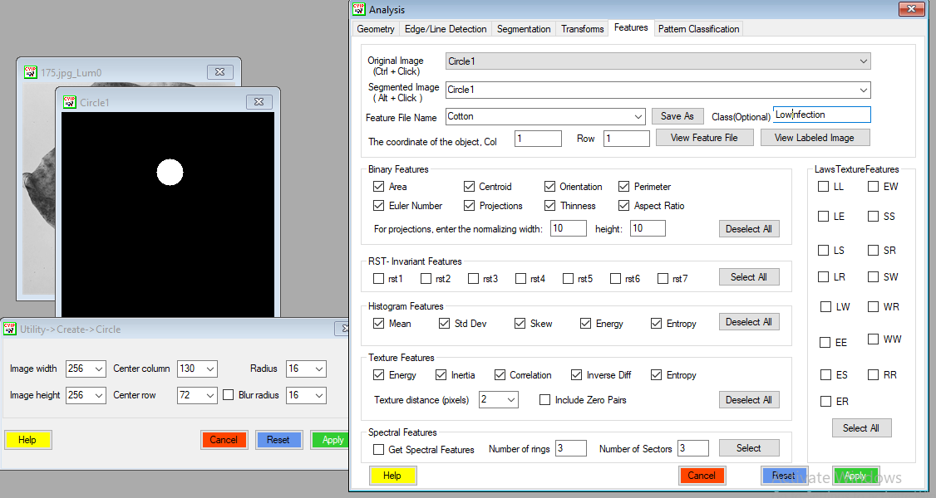
Figure 3
CVIPtools Feature Extraction Interface Showing the Binary, RST-Invariant, Histogram, and Texture Feature Categories Selected for Each Segmented ROI (Example: Low Infection Class)

Figure 3 shows the CVIPtools interface used to compute the 55-feature set described in Sections 3.5.1-3.5.3. For every ROI, the binary shape descriptors (The extracted features include object area, centroid position, orientation, boundary perimeter, Euler characteristic, projection-based measure-ments, shape thinness, and aspect ratio) Seven rotation- and scale-invariant moments, five histogram-based statistical measures (mean, standard deviation, skewness, energy, and entropy), and five GLCM/Haralick texture features (energy, inertia, correlation, inverse difference, and entropy). Were computed and exported with the class label to a feature file for feature selection and classification.

3.6 Feature Selection
The initial feature extraction produced 55 candidate features per ROI. Because high-dimensional feature sets increase computational cost, introduce redundant variables, and increase overfitting risk (Jović et al., 2015; Lutu & Andries, 2010; Zebari et al., 2020), Correlation-based Feature Selection (CFS) was applied to classify the maximum discriminative and least redundant subset. CFS evaluates candidate subsets according to a heuristic favoring features that correlate highly with the target class while correlating weakly with one another, retaining features that are individually predictive without being mutually redundant. Applying CFS to the 55-feature set reduced dimensionality to 20 optimal features used for all classification experiments.
Formally, the merit of a candidate feature subset S containing k features is defined as:
$${Merit}_{S}=\frac{k {\overset{‾}{r}}_{cf}}{\sqrt{k+k\left(k-1\right) {\overset{‾}{r}}_{ff}}}$$  CFS merit | (52)
where r̄_{cf} is the mean feature-class correlation and r̄_{ff} is the mean feature-feature inter-correlation over the features in S; the subset with the highest merit is retained. Table 3 lists the final selected set.
Table 3
Feature Set Selected via Correlation-Based Features Selection
Feature Category | Selected Features | Count
Shape / Binary Features | Object row coordinate, Object column coordinate, Area, Centroid (row), Centroid (column), Second moment, Perimeter, Euler number | 8
Projection Features | Projections 1-11 (normalized row and column projection profiles) | 11
Total | — | 19
The final feature set retained by CFS is dominated by shape-based binary descriptors and their associated projection profiles, which characterize the geometry and spatial mass distribution of the segmented lesion region within each ROI. Together with the class label, this corresponds to the 20-attribute feature file used to train and evaluate all classifiers reported in Section 4.

3.7 Classification Algorithms
The 20 selected features for each ROI were used to train and evaluate sixteen classification algorithms - twelve conventional machine learning classifiers and four deep learning models-all executed and evaluated within Weka machine learning workbench, consistent with a similar Weka-based evaluation of cotton leaf classification reported by Patil and Burkpalli (2021).

3.7.1 Machine Learning Classifiers
The evaluated classifiers were: Lazy.IB1, an instance-based nearest-neighbour classifier; Lazy.IBK, a generalized k-nearest-neighbour classifier; Trees.RandomTree, a single randomizable decision tree; Meta.RandomCommittee, an ensemble of randomizable base classifiers trained with different random seeds; Trees.RandomForest, a bagged ensemble of random decision trees; Rules.NNge, a nearest-neighbour-like rule induction classifier that generalizes exemplars into hyper-rectangles; Meta.RotationForest, a PCA-based rotation ensemble classifier; Meta.Decorate, a diversity-based ensemble trained on real and artificially generated examples; Trees.SimpleCart, a CART implementation; Trees.J48, the C4.5 decision tree algorithm; Trees.J48graft, a grafted C4.5 variant; and Trees.BFTree, a best-first decision tree. This panel spans lazy, rule-based, tree-based, and ensemble learning paradigms, allowing a comprehensive comparison of strategies on the same feature-selected dataset.

3.7.2 Deep Learning Models

To provide a comparison with conventional machine learning methods, four deep learning architectures were evaluated using the extracted and selected feature vectors: a Convolutional Neural Network (CNN), a Long Short-Term Memory (LSTM) network, a Bidirectional Long Short-Term Memory (Bi-LSTM) network, and a Multi-Layer Perceptron (MLP). Unlike conventional image-based deep learning approaches that operate directly on raw pixels, these models received the pre-extracted feature vectors as input. This setup allowed the study to examine whether deep learning architectures could effectively capture complex and non-linear relationships among the selected features and provide better classification performance than traditional machine learning classifiers.

3.8 Evaluation Metrics

The classifiers were evaluated using a range of standard performance measures for multiclass classification. The analysis was performed separately for the three infection categories-Low, Normal, and High-and also included weighted-average results. The True Positive (TP) Rate, or recall/sensitivity, measures the proportion of samples from a given class that are correctly recognized. In contrast, the False Positive (FP) Rate indicates how frequently samples belonging to other classes are incorrectly classified as the target class. Precision represents the proportion of correctly identified samples among all samples predicted as a particular class. The F-Measure provides a combined assessment of precision and recall. The ROC Area evaluates how effectively a classifier separates different classes across varying decision thresholds, with values ​​approaching 1.0 indicating stronger discriminatory capability. To provide a more comprehensive assessment, the study also reports overall accuracy, Cohen's Kappa, Mean Absolute Error (MAE), and Root Mean Square Error (RMSE). Together, these measures provide a broader view of the classifiers’ reliability and effectiveness in distinguishing the different levels of bacterial blight infection.

3.9 Experimental Setup

The CVIPtools software package was used for the first few stages of image processing, which included pre-processing the image, ROI extraction, and feature extraction. The data that was derived through feature extraction was then saved in the ARFF format and used in Weka for feature selection, training the classifier, and evaluating the model's performance. The evaluation was done by means of applying the 10-fold cross-validation approach. According to this approach, the entire dataset is split into ten subsets that are approximately of the same size. In every trial, nine of these subsets were used for training the classifier, while one subset was used for testing. The experiment was conducted ten times; in each trial, a different subset served as the test set. The scores from all ten trials were averaged to obtain the final evaluation results.

3.10 Algorithm of the Proposed Framework
Summary of Algorithm 1 shows the entire process flow of the suggested method that includes all main stages starting from image pre-processing up to feature extraction, feature selection, and classification. The feature extraction, selection, and classification processes were independently conducted for each predefined ROI size so that the influence of ROI granularity on classification performance can be compared; in this study the best result (Lazy.IB1, 93.33%) was obtained on the 16×16 ROI feature set.
Algorithm 1
Feature-Based Classification of Cotton Bacterial Blight Severity
Input: Image set D = {(I_{n}, y_{n})}, n = 1, …, 900, with y_{n} ∈ {Low, Normal, High}; ROI sizes S = {256×256, 16×16}; classifier set C of 12 machine learning and 4 deep learning models; number of folds K = 10.
Output: Performance metrics of every classifier and the best-performing classifier c* with its ROI size s*.
Stage 1 – Pre-processing
1: for each image I_{n} in D do
2: I_{n} ← Resize(I_{n}, 256 × 256)
3: G_{n} ← Grayscale(I_{n}) (luminance-weighted, CVIPtools)
4: G_{n} ← Enhance(G_{n}) (contrast enhancement and noise reduction)
5: end for
Stage 2 – ROI segmentation, feature extraction and selection
6: for each ROI size s in S do
7: for each image G_{n} do
8: R_{n} ← ExtractROI(G_{n}, s); B_{n} ← Threshold(R_{n})
9: v_{hist} ← histogram features of R_{n} (Eqs. (1)–(5))
10: v_{glcm} ← GLCM/Haralick features of R_{n} (Eqs. (26)–(51))
11: v_{bin} ← binary shape features of B_{n} (Eqs. (6)–(16))
12: v_{rst} ← RST-invariant moments of B_{n} (Eqs. (17)–(25))
13: x_{n} ← [v_{hist}, v_{glcm}, v_{bin}, v_{rst}] (55 features)
14: end for
15: D_{s} ← {(x_{n}, y_{n})}; D_{s}* ← CFS(D_{s}), retaining the subset of maximum merit, Eq. (52) (20 features)
16: Export D_{s}* in ARFF format
Stage 3 – Classification and evaluation
17: for each classifier c in C do
18: Partition D_{s}* into K folds
19: for k = 1 to K do
20: Train c on the remaining K − 1 folds and test on fold k
21: Record TP rate, FP rate, precision, recall, F-measure, ROC area, accuracy, kappa, MAE and RMSE
22: end for
23: Average all metrics over the K folds
24: end for
25: end for
26: return the classifier c* and ROI size s* with the highest weighted-average accuracy

4. Results and Discussion
This section describes the experimental assessment carried out to evaluate the effectiveness of the proposed framework using the dataset and methodology of Section 3. Experiments covered five ROI sizes (256×256 and 16×16 pixels) using the 20 features retained after correlation-based feature selection. Twelve machine learning classifiers and four deep learning models were evaluated through 10-fold cross-validation using a range of performance measures, including the TP rate, FP rate, precision, recall, F-measure, and ROC area. Kappa, MAE, RMSE, and overall accuracy, as described in Section 3.8.
Across all ROI sizes, the 16×16 configuration consistently produced the highest accuracy for the top-performing classifiers, indicating that fine-grained local texture patterns carry strong discriminative information for distinguishing Low, Normal, and High bacterial blight severity. On this configuration, Lazy.IB1 achieved the highest overall accuracy (93.33%), followed by Lazy.IBK (93.22%). At the 256×256 ROI size, Lazy.IB1 again led at 93.22%, while Meta.RandomCommittee and Meta.RotationForest achieved 92.96% and 90.89% respectively. All twelve classifiers are compared in detail in Section 4.2.

4.1 Detailed Accuracy and Confusion Matrix Analysis
Table 4 presents the per-class accuracy of the Lazy.IB1 classifier on the 16×16 ROI feature set, which produced the best overall performance.
Table 4
Detailed Accuracy by Class (Lazy.IB1 Classifier, ROI Size 16×16)
Classes | TP Rate | FP Rate | Precision | Recall | F-Measure | ROC Area | Accuracy (%)
Low Infection | 0.913 | 0.037 | 0.925 | 0.913 | 0.919 | 0.938 | 94.63
Normal Infection | 0.940 | 0.038 | 0.926 | 0.940 | 0.933 | 0.951 | 95.48
High Infection | 0.947 | 0.025 | 0.950 | 0.947 | 0.948 | 0.961 | 96.56
Weighted Avg. | 0.933 | 0.033 | 0.933 | 0.933 | 0.933 | 0.950 | 93.33
The High Infection class was classified with the highest per-class accuracy (TP Rate = 0.947), followed by Normal Infection (0.940) and Low Infection (0.913)-consistent with the expectation that severely infected leaves show more pronounced, spatially extensive textural changes, whereas Low Infection leaves, differing from healthy tissue only subtly, are more prone to misclassification.
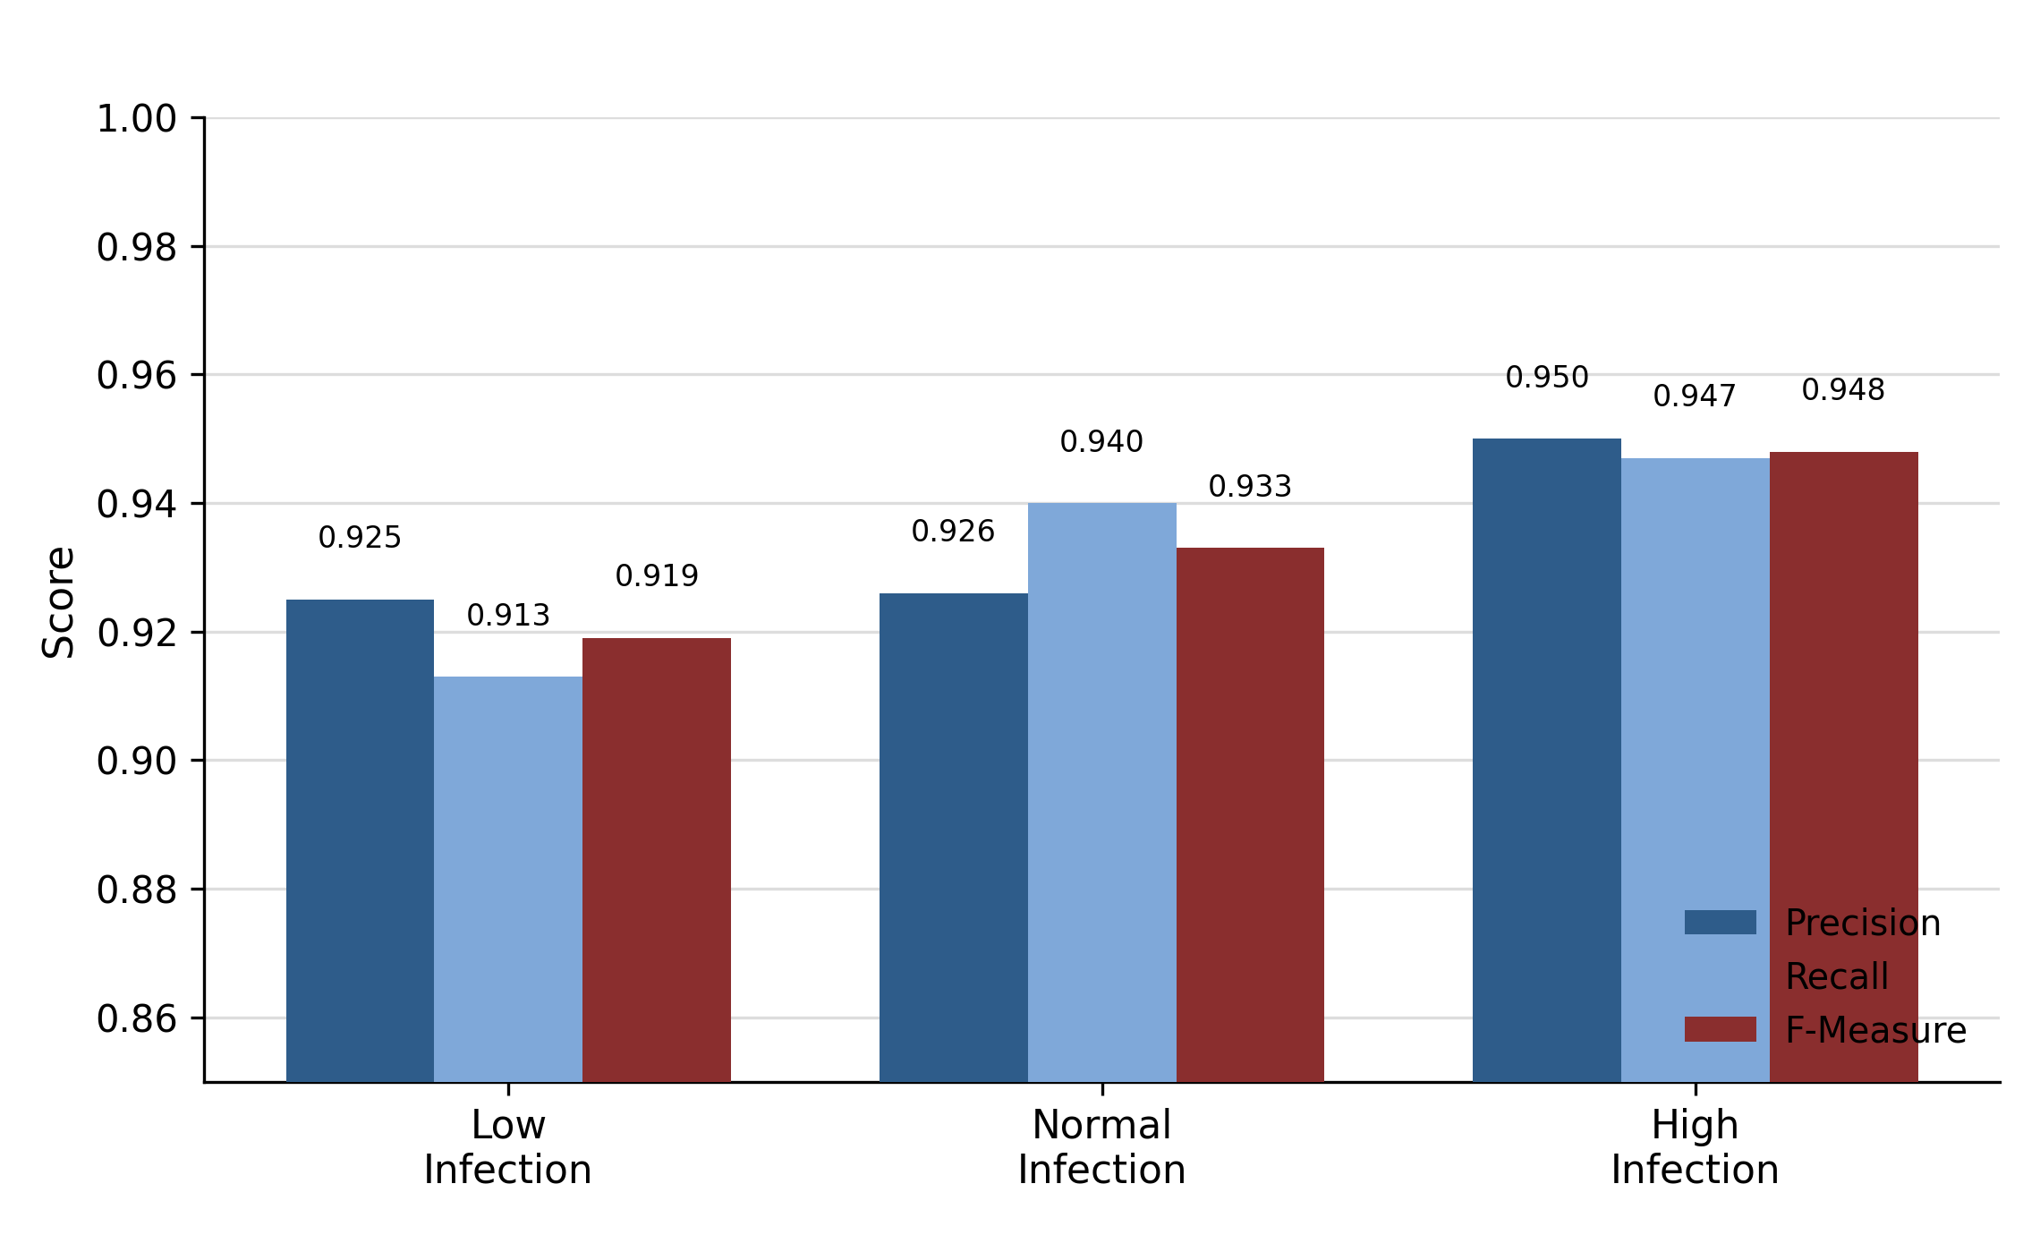

Table 5
Confusion Matrix - Lazy.IB1 Classifier (ROI Size 16×16)
Actual \ Predicted | Low Infection | Normal Infection | High Infection | Total
Low Infection | 822 | 50 | 28 | 900
Normal Infection | 37 | 846 | 17 | 900
High Infection | 30 | 18 | 852 | 900
Total | 889 | 914 | 897 | 2700
Table 5 shows strong diagonal dominance, with 822, 846, and 852 correctly classified instances for the Low, Normal, and High infection classes respectively, out of 900 test instances per class (2,700 total) under 10-fold cross-validation. Most confusion occurs between Low and Normal Infection (50 Low misclassified as Normal; 37 Normal misclassified as Low), consistent with the textural similarity of early-to-moderate symptom progression, whereas confusion between the texturally distinct Low and High classes is comparatively rare (28 and 30 instances).
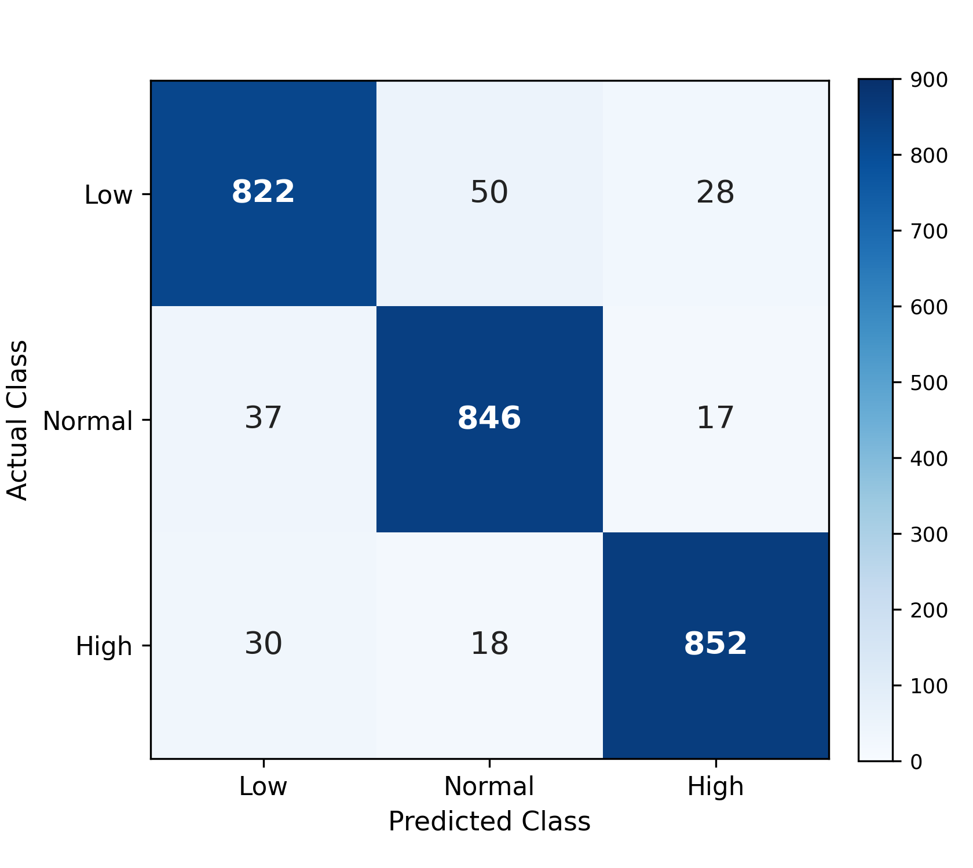
Figure 5
Confusion Matrix Heat Map-Lazy.IB1 Classifier (ROI 16×16)

For comparison, Table 6 and Table 7 present the same breakdown for the second-best classifier, Lazy.IBK (93.22% accuracy), which shows a nearly identical class-separation pattern.
Table 6
Detailed Accuracy by Class (Lazy.IBK Classifier, ROI Size 16×16)
Classes | TP Rate | FP Rate | Precision | Recall | F-Measure | ROC Area | Accuracy (%)
Low Infection | 0.912 | 0.038 | 0.922 | 0.912 | 0.917 | 0.963 | 94.44
Normal Infection | 0.938 | 0.038 | 0.924 | 0.938 | 0.931 | 0.972 | 95.30
High Infection | 0.947 | 0.025 | 0.950 | 0.947 | 0.948 | 0.976 | 96.52
Weighted Avg. | 0.932 | 0.034 | 0.932 | 0.932 | 0.932 | 0.970 | 93.22
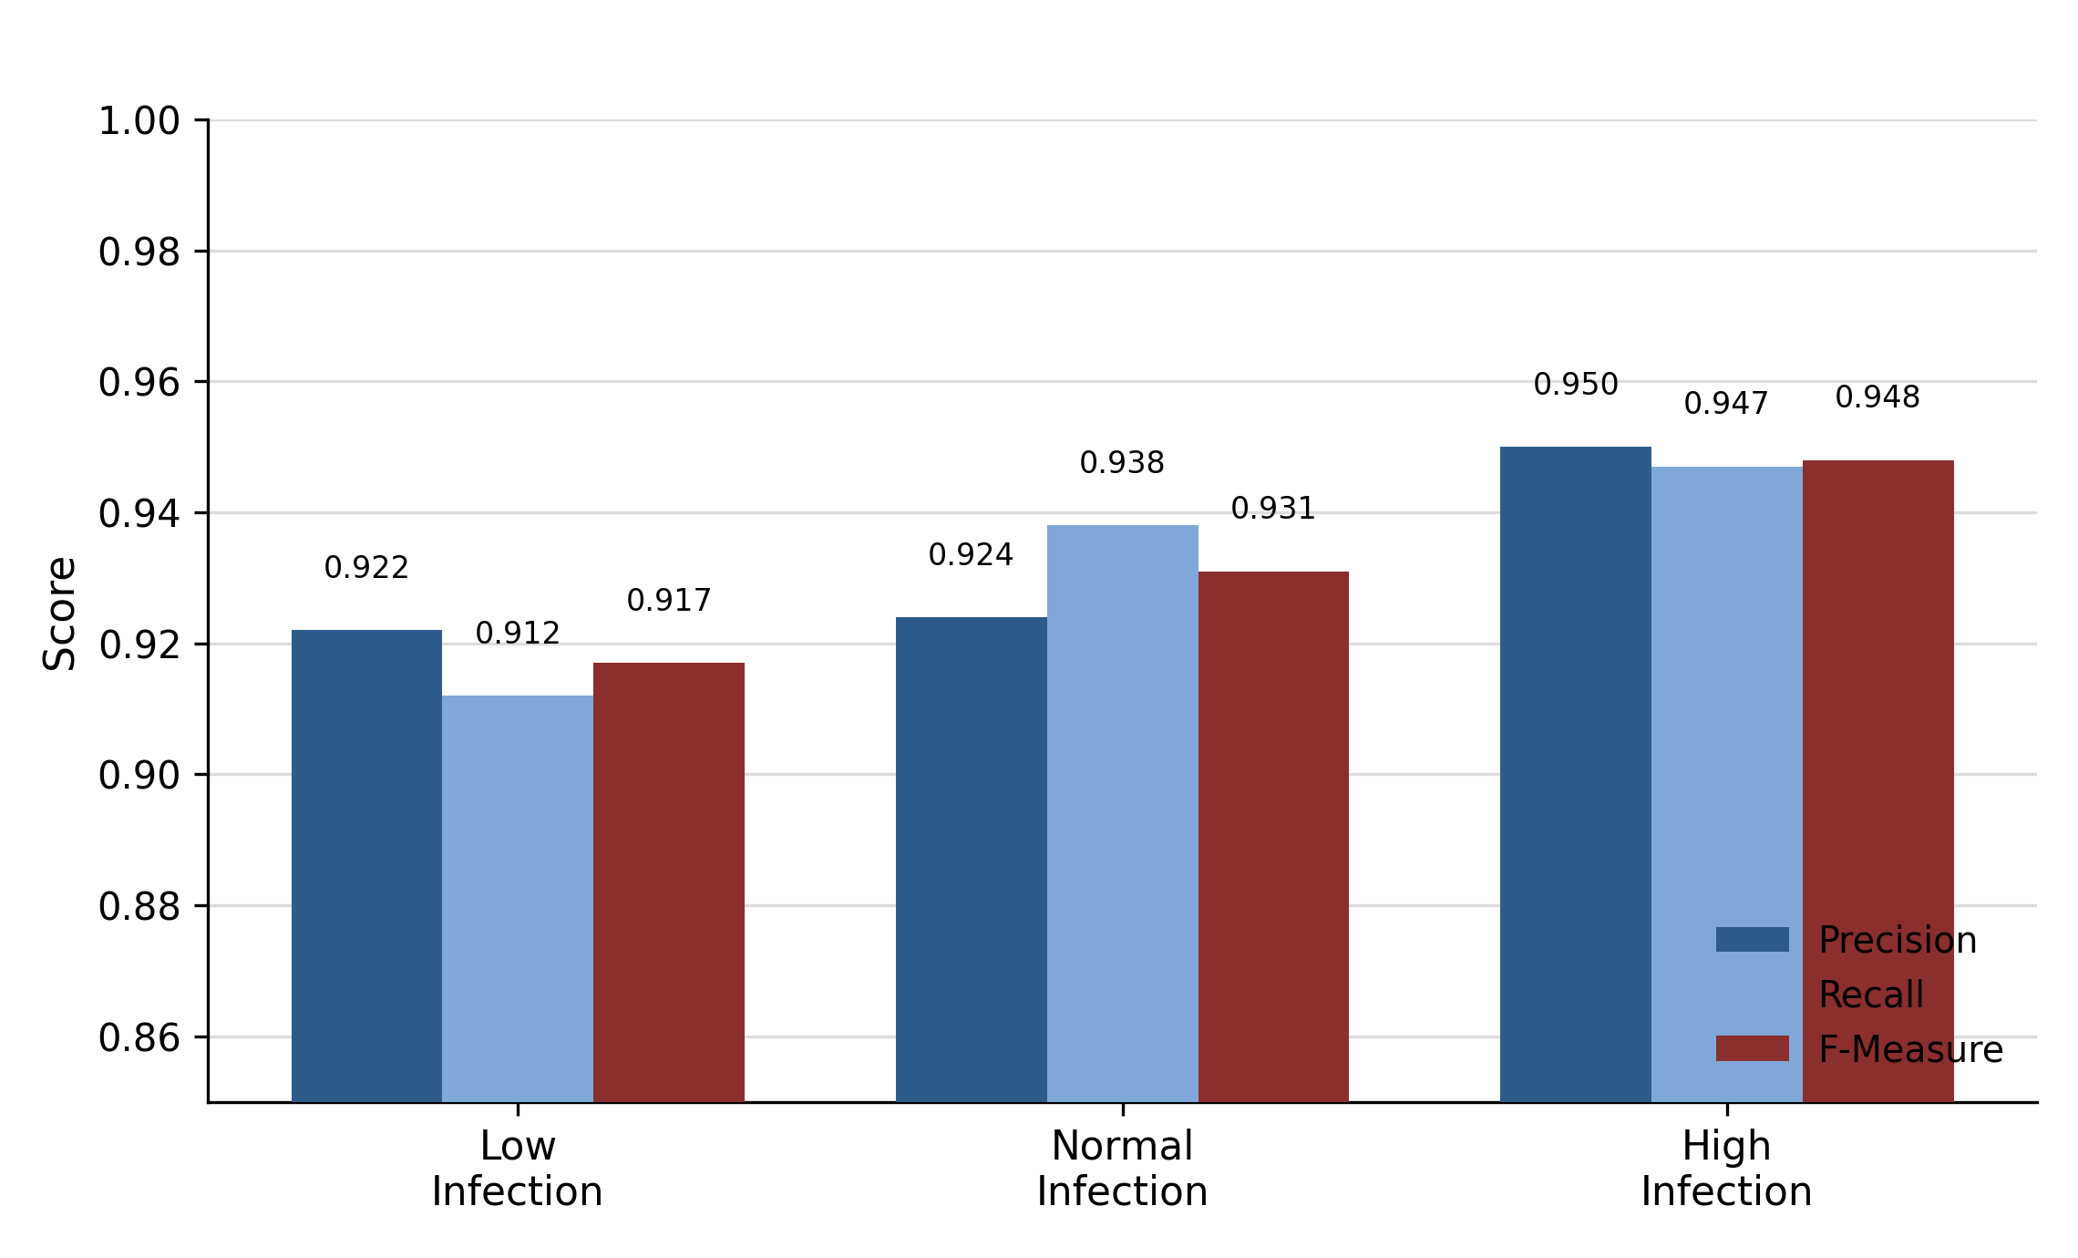
Figure 6
Per-Class Precision, Recall, and F-Measure (Lazy.IBK, ROI 16×16)
Lazy.IBK: High Infection has the highest F-Measure (0.948) and Low Infection the lowest (0.917).
Table 7
Confusion Matrix-Lazy.IBK Classifier (ROI Size 16×16)
Actual \ Predicted | Low Infection | Normal Infection | High Infection | Total
Low Infection | 821 | 51 | 28 | 900
Normal Infection | 39 | 844 | 17 | 900
High Infection | 30 | 18 | 852 | 900
Total | 890 | 913 | 897 | 2700
For completeness, Figures 7-9 present the same per-class breakdown for three additional classifiers spanning different learning paradigms, Trees.RandomTree, Trees.RandomForest, and Meta.RandomCommittee-all on the 16×16 ROI feature set. The following trends can be detected throughout all the models tested. The category of High Infection tends to provide the best values for Precision, Recall, and F-Measure, while Normal Infection is second. On the contrary, the category of Low Infection is the hardest one to classify accurately. From this we may assume that the problem of differentiating between the Low and Normal Infection categories stems more from the similarities in textures of early lesions

.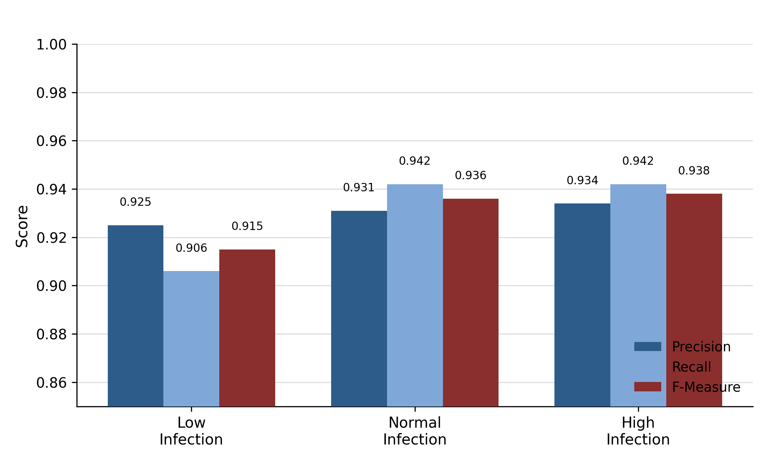
Figure 7
Per-Class Precision, Recall, and F-Measure (Trees.RandomTree, ROI 16×16)
The RandomTree classifier shows an improvement in F-Measure across the infection levels, increasing from 0.915 for Low Infection to 0.938 for High Infection.
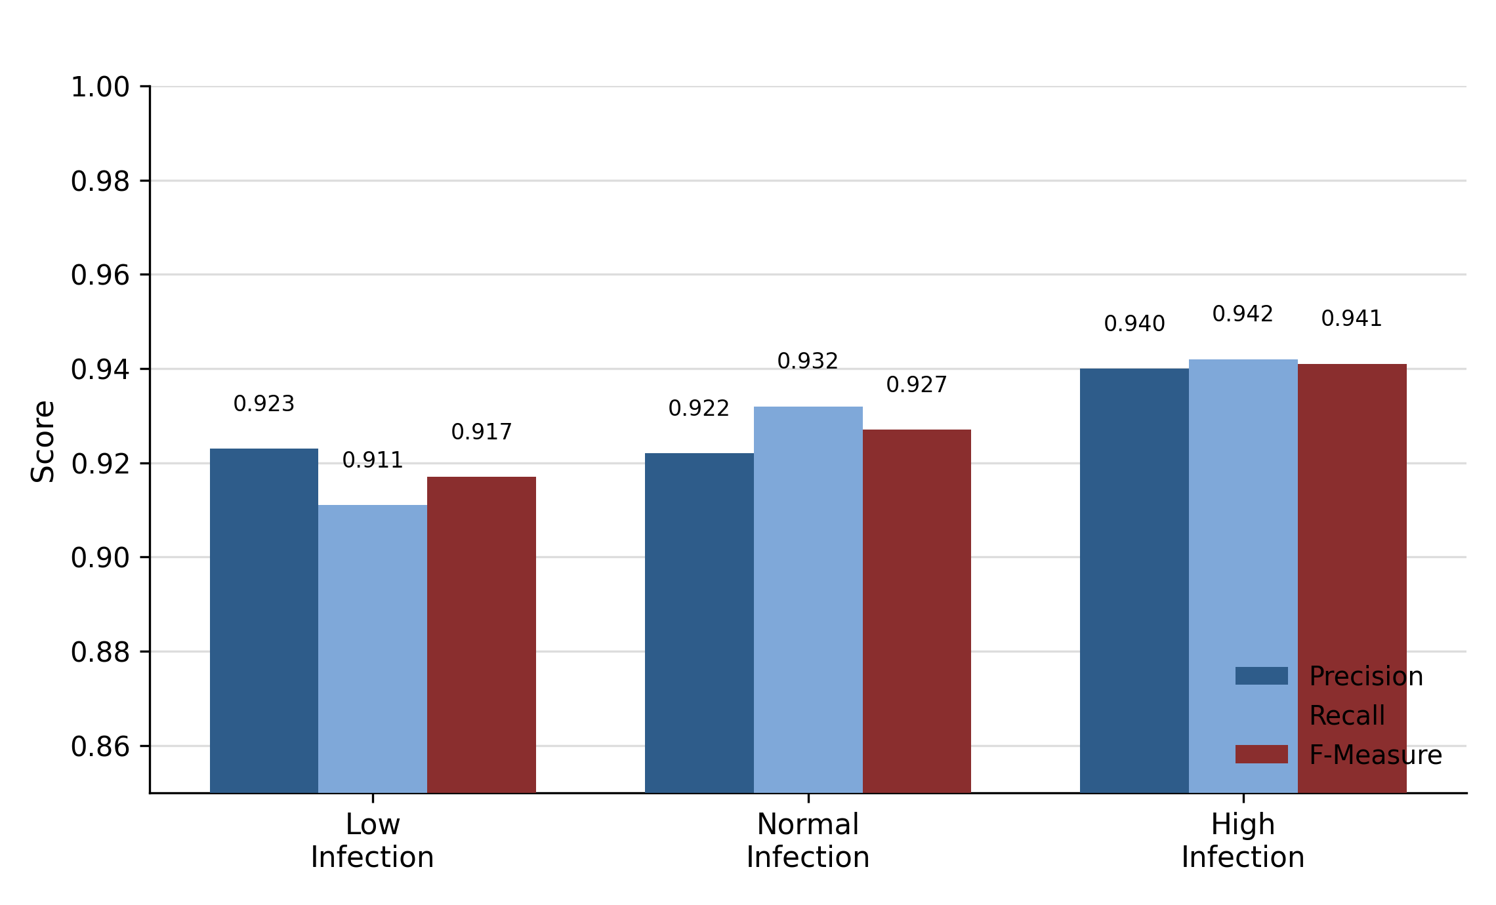
Figure 8
Per-Class Precision, Recall, and F-Measure (Trees.RandomForest, ROI 16×16)
Trees.RandomForest: High Infection scores best (F-Measure 0.941) and Low Infection lowest (0.917).
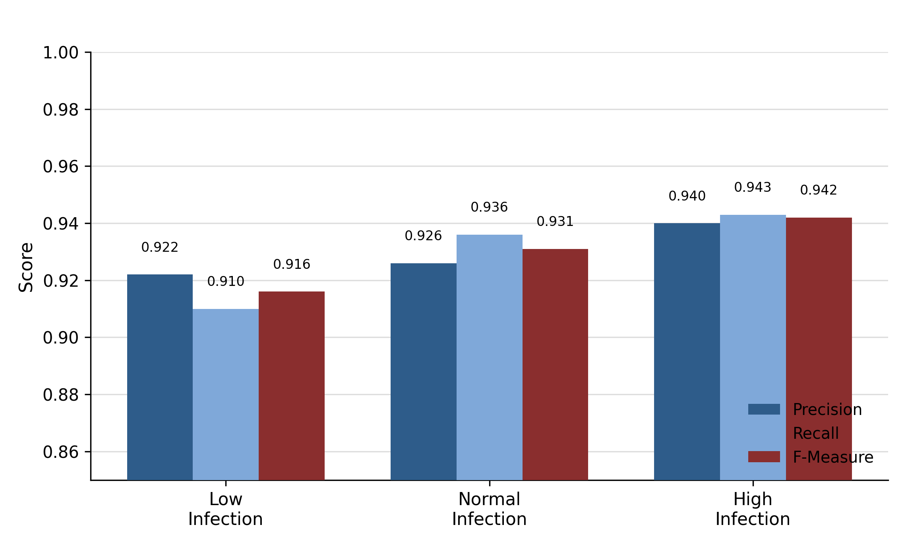
Figure 9
Per-Class Precision, Recall, and F-Measure (Meta.RandomCommittee, ROI 16×16)
Meta.RandomCommittee: F-Measure is highest for High Infection (0.942) and lowest for Low Infection (0.916).

4.2 Comparative Analysis of Classifiers
Table 8 provides the weighted-average performance of all twelve machine learning classifiers based on 16×16 ROI feature set. The performance measures considered include Kappa Statistic (KS), Mean Absolute Error (MAE), Relative Absolute Error (RAE), True Positive Rate (TPR), False Positive Rate (FPR), F-score, Mathews Correlation Coefficient (MCC), ROC Area, and overall accuracy. The twelve classifiers have been sorted in decrescendo of their accuracies. MCC has been calculated based on the three-class confusion matrix of each classifier using Gorodkin’s generalization of multiclass. Table 8
Detailed Accuracy Metrics of All Machine Learning Classifiers (ROI Size 16×16)
Classifier | KS | MAE | RAE (%) | TP Rate | FP Rate | F-Score | MCC | ROC | Accuracy (%)
IB1 | 0.900 | 0.0444 | 10.00 | 0.933 | 0.033 | 0.933 | 0.900 | 0.950 | 93.33
IBK | 0.898 | 0.0451 | 10.16 | 0.932 | 0.034 | 0.932 | 0.898 | 0.970 | 93.22
RandomTree | 0.895 | 0.0468 | 10.53 | 0.930 | 0.035 | 0.930 | 0.895 | 0.947 | 93.00
Random Committee | 0.894 | 0.0471 | 10.60 | 0.930 | 0.035 | 0.930 | 0.894 | 0.974 | 92.96
RandomForest | 0.893 | 0.0645 | 14.52 | 0.929 | 0.036 | 0.928 | 0.893 | 0.976 | 92.85
NNge | 0.890 | 0.0489 | 11.00 | 0.927 | 0.037 | 0.927 | 0.890 | 0.945 | 92.67
Rotation Forest | 0.863 | 0.0900 | 20.24 | 0.909 | 0.046 | 0.909 | 0.863 | 0.979 | 90.89
Decorate | 0.815 | 0.1505 | 33.86 | 0.877 | 0.062 | 0.876 | 0.815 | 0.957 | 87.67
SimpleCart | 0.798 | 0.1043 | 23.46 | 0.866 | 0.067 | 0.865 | 0.799 | 0.947 | 86.56
J48 | 0.782 | 0.1113 | 25.05 | 0.855 | 0.073 | 0.854 | 0.783 | 0.946 | 85.48
J48graft | 0.782 | 0.1113 | 25.05 | 0.855 | 0.073 | 0.854 | 0.783 | 0.946 | 85.48
BFTree | 0.748 | 0.1225 | 27.56 | 0.832 | 0.084 | 0.831 | 0.749 | 0.942 | 83.19

Instance-based lazy learners (Lazy.IB1, Lazy.IBK) and ensemble/tree-based methods (Trees.RandomTree, Meta.RandomCommittee, Trees.RandomForest, Rules.NNge) consistently outperformed the remaining classifiers, all achieving Kappa and MCC above 0.89 and RAE below 15% -strong agreement beyond chance and low relative prediction error. Meta.RotationForest achieved a markedly higher ROC Area (0.979) than the top-ranked classifiers despite lower accuracy (90.89%) and MCC (0.863), illustrating that ranking by accuracy alone can understate discriminative capability across thresholds. The two C4.5-based classifiers, Trees.J48 and Trees.J48graft, produced numerically identical results (85.48% accuracy), indicating that grafting did not alter the decision boundaries learned on this feature set. Trees.BFTree recorded the lowest accuracy (83.19%), lowest MCC, and highest MAE/RAE among all twelve classifiers. Among the deep learning models evaluated on the same feature-selected data, the CNN and MLP achieved substantially lower accuracies of approximately 33.33%, while a Naïve Bayes baseline achieved 63.75% - indicating that deep architectures did not effectively exploit the already-compact, hand-engineered feature representation and were outperformed by every one of the twelve machine learning classifiers. This is consistent with broader observation that deep networks realize their comparative advantage when applied directly to raw, high-dimensional image data, rather than to low-dimensional, pre-extracted feature vectors.
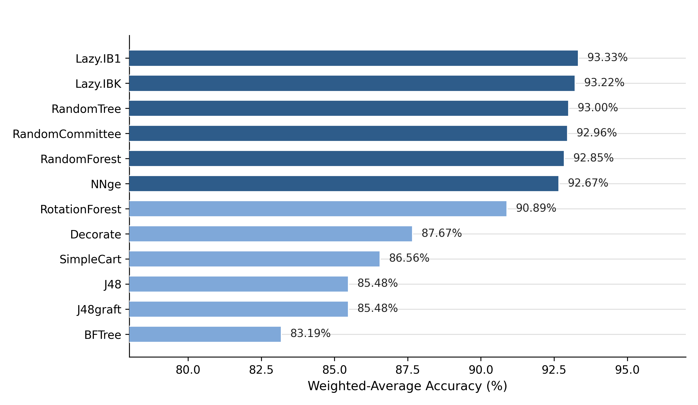
Figure 10
Classification Accuracy of Machine Learning Classifiers (ROI 16×16)
. Lazy.IB1 leads with 93.33% accuracy, while Trees.BFTree is lowest at 83.19%.
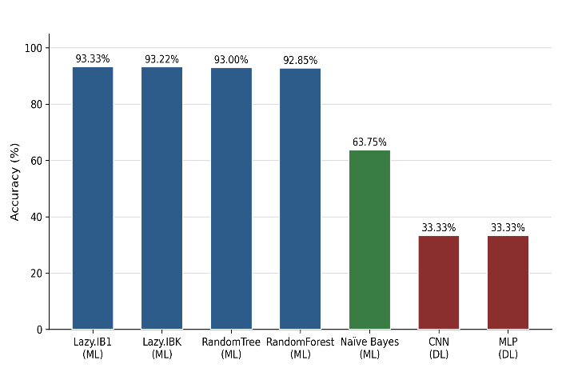
Figure 11
Machine Learning vs. Deep Learning Models on the Selected Feature Set
Lazy.IB1 achieved the highest accuracy (93.33%), whereas the CNN and MLP deep learning models reached only 33.33% on the same selected feature set.

4.3 Effect of Region-of-Interest Size on Classification Accuracy
To assess sensitivity to ROI granularity, the top-performing classifiers were also evaluated on the coarser 256×256 ROI configuration and compared against 16×16. Comparison of the three best classifiers is provided in Table 9 for all configurations considered in the research.
Table 9
Classification Performance at Different ROI Segment Sizes
ROI Size | Lazy.IB1 (%) | Lazy.IBK (%) | Best Ensemble Classifier (%)
256 × 256 | 93.22 | 93.22 | 92.96 (Random Committee)
16 × 16 | 93.33 | 93.22 | 92.93 (Random Committee)
The accuracies of the instance-based classifier and the ensemble classifier were fairly stable in terms of the ROI configurations evaluated. There was a small increase in accuracy for the Lazy.IB1 classifier when the finest ROI configuration was used, and the accuracy rose from 93.22% to 93.33%. This stability suggests that the features extracted contain important information about the disease regardless of spatial scale. The robustness is advantageous for real-life applications since it reduces the dependency on the ROI sizes chosen during image analysis.
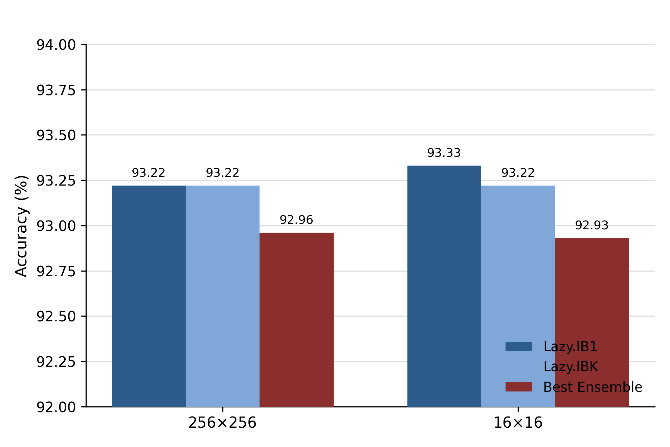
Figure 12
Effect of ROI Segment Size on Classification Accuracy

4.4 Comparison with Existing Literature
Table 10 benchmarks the proposed framework against previously published approaches for cotton leaf disease and bacterial blight detection, discussed in Section 2.
Table 10
Comparison of the Proposed Framework with State-of-the-Art Cotton Disease Detection Studies
Reference | Technique / Methodology | Classifier / Model | Accuracy (%)
Anwar, Rahim Kolachi, et al. (2023) | CNN with fuzzy k-means clustering | CNN | 93.33
Kumar Gudela et al. (2023) | Feature-based classification (SVM / KNN) | SVM, KNN | 93.00 / 93.22
Islam et al. (2023) | Fine-tuned transfer learning (Xception best) | CNN | 98.70
M. Shao et al. (2023) | Bilinear coordinate attention enhancement | CNN | 96.61
Y. Shao et al. (2024) | Attention-based CNN (natural field conditions) | CNN | 96.30-98.60
Akbar et al. (2024) | GAN augmentation with VGG16/Inception V3/ResNet50 | CNN ensemble | 95.00
Anwar, Soomro, et al. (2023) | Deep transfer learning benchmark (6 pretrained CNNs) | CNN | 96.00
Suleman Memon et al. (2022) | Meta deep learning model | CNN | 98.53
Proposed Method | Texture + Histogram + Binary + RST features with CFS | Lazy.IB1 | 93.33
Several recent deep-learning-based studies report higher accuracy than the proposed framework, particularly those using transfer learning with large pretrained backbones on binary or small-category tasks (Akbar et al., 2024; Anwar, Soomro, et al., 2023; Islam et al., 2023; Shao et al., 2023; Shao et al., 2024; Suleman Memon et al., 2022). However, these studies generally address coarser disease categories-healthy-versus-diseased or a small number of visually distinct classes - and rely on substantially larger, pretrained architectures with correspondingly higher computational and data requirements. By contrast, the proposed framework performs finer-grained three-class severity classification using a compact 20-feature representation and a lightweight instance-based classifier, achieving 93.33% accuracy-comparable to or better than several reviewed deep learning studies, including Anwar, Rahim Kolachi, et al. (2023) and Kumar Gudela et al. (2023),while requiring substantially less training data, computation, and model complexity. The proposed framework provides an interpretable and computationally efficient approach for supporting disease assessment in agricultural settings with limited computing resources, enabling faster analysis without relying on high-end hardware.
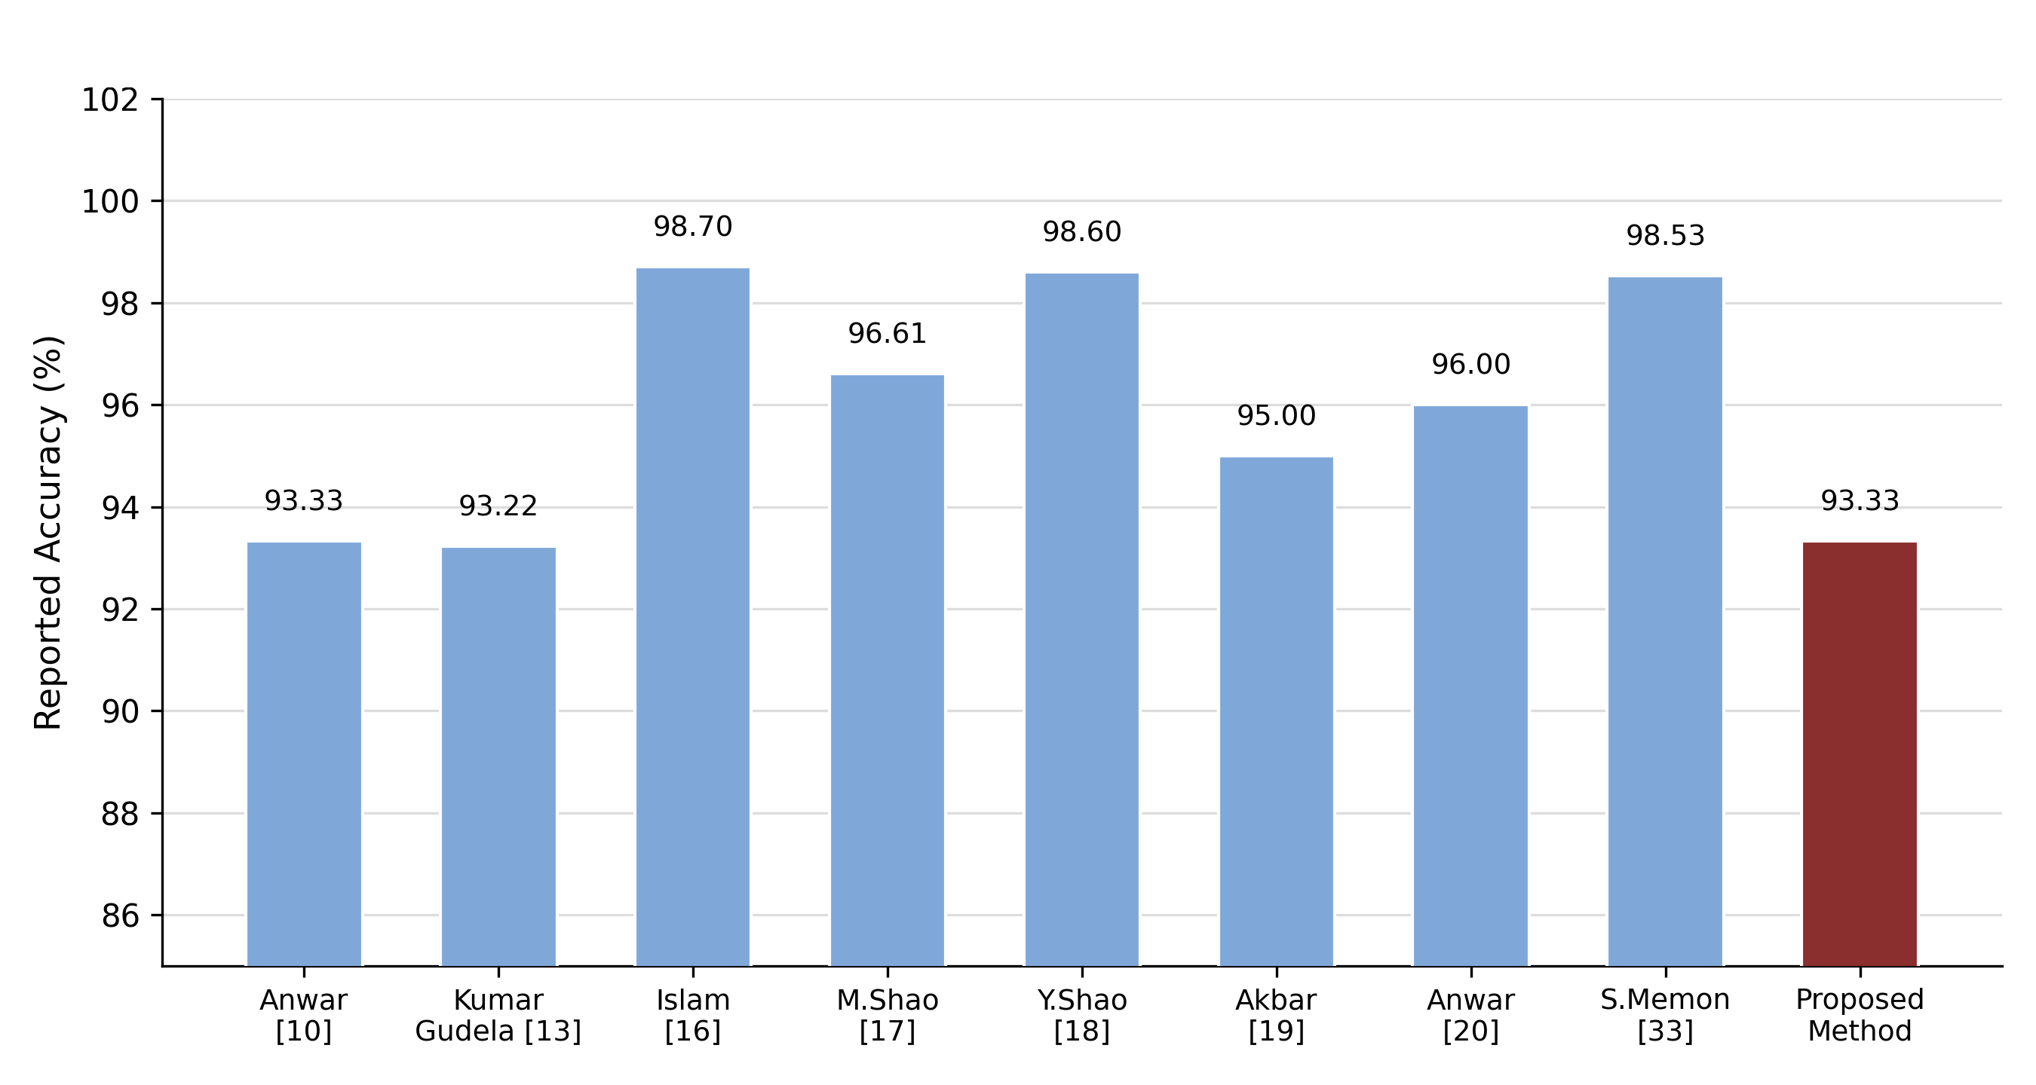
Figure 13: Proposed Framework vs. State-of-the-Art Cotton Disease Detection Studies

4.5 Computational Efficiency Considerations
Beyond accuracy, computational efficiency matters for diagnostic tools deployed on resource-constrained hardware such as smartphones or low-cost embedded devices. The classifiers evaluated here operate on a compact 20-dimensional feature vector per ROI, and instance-based methods such as Lazy.IB1 require no explicit training phase beyond storing labelled instances, classifying a new sample using only distance computation against the stored set. This contrasts with the CNN and other deep learning models reviewed in Section 2, which require iterative gradient-based training over many epochs, larger volumes of labelled data, and a forward pass through many layers at inference. While a formal wall-clock benchmark was not performed, the substantial difference in model and input dimensionality implies a correspondingly large difference in training time, memory footprint, and inference latency-favoring the feature-based approach where computational resources, connectivity, or annotated training data are limited, such as smallholder farms in remote agricultural regions of Pakistan.

4.6 Discussion
The results support three main observations. First, the combination of texture, histogram, binary, and RST invariant features, refined through correlation-based feature selection, is sufficient to separate three bacterial blight severity categories with high accuracy without pixel-level representation learning. Second, among the sixteen classifiers, instance-based lazy learners and ensemble methods consistently outperformed single decision trees and the deep learning models on the same feature set, suggesting that classifier choice should match the dimensionality and structure of the input representation. Third, the 16×16 ROI configuration produced better results than the coarser segmentation settings, suggesting that fine-scale textural characteristics contain important information for identifying early and moderate levels of infection. In general, the results show that feature-based machine vision can offer a practical alternative to the high computational needs of deep learning models. With lower computational needs and greater transparency of the algorithm, the approach would be especially useful in scenarios when the dataset, computing power, or the need for transparency in decision-making limits the implementation of the deep learning model. Furthermore, the suggested model can offer a more comprehensive assessment by classifying the cotton leaves not only as healthy or diseased but as either Low, Normal, or High infection. Severity-based assessment can help to make more informed decisions regarding field management. For instance, Low infection leaves should be monitored, Normal leaves should receive specific disease control measures, whereas High infection leaves should indicate the removal of plant material and management at the field level. As bacterial blight is known to result in yields decreases of 12-33% depending on the crop growth phase at which disease was detected (Borkar et al., 2024; Sowmiya et al., 2022), more accurate and faster assessment of the disease can help to minimize these losses. Any improvement compared to the accuracy of visual assessment in the field (approximately 88%), which was described in the literature (Mehmood et al., 2023), could be valuable when applied on a large scale.
5. Conclusion

The proposed study designed a feature-based machine vision method to classify the infection severities of bacterial blight in cotton leaves into three categories: Low, Normal, and High. First, a dataset of 900 cotton leaf images underwent the following basic pre-processing techniques: resizing, converting images to greyscale and image enhancement. Then, a variety of texture, histogram, binary and rotation, scale and translation (RST) invariant features were extracted from ROIs at various pixel resolutions via CVIPtools. Of the total number of 55 initially extracted features, the 20 features selected via correlation-based feature selection were informative and non-redundant, thus, they served as input for the classification task. Twelve classical machine learning algorithms and four deep learning models available in Weka were trained and their performance was evaluated on 10-fold cross validation on the aforementioned 20 selected features. The best performance among the tested algorithms was observed by Lazy.IB1 (instance-based) classifier with weighted-average accuracy of 93.33%. Its performance outperformed that of Lazy.IBK, the two other instance-based tree-based classifiers evaluated and all four deep learning models. The results suggest that a well-selected set of features allows obtaining high-performance classification, while the need for deep learning is questionable. In addition, the feature-based approach provides certain advantages in terms of computational complexity and model interpretation compared to the deep learning approach, which makes it more applicable to the agricultural environment where there can be some limitation in the number of training examples or computing facilities. Thus, the proposed framework constitutes a practical foundation for the automatic assessment of bacterial blight in cotton leaves. Being capable of distinguishing between Low, Normal and High infection severities, the proposed method provides more useful information than the basic healthiness/diseaseness classification and will be able to help farmers and agricultural extension workers make timely decisions regarding disease management. With further development and validation using larger and more diverse datasets, the proposed framework can become a valuable part of the automated crop health monitoring system. diverse field datasets, the approach could contribute to the development of affordable and accessible decision-support systems for cotton disease monitoring and improved crop management.

5.1 Limitations

There exist some limitations of this study that need to be taken into account while interpreting the results. Firstly, the analysis involved only three infection severity levels without including the leaves that were completely healthy or had severe infection. Secondly, the data set used was derived from a relatively small number of fields and geographical areas where images were taken with certain lighting. Thus, the performance of the suggested method could be different in case of its application in other climate zones, different varieties of cotton, fields or imaging equipment. Thirdly, the classification was based only on the visible symptoms that could be similar to the ones for other diseases. Finally, the environment variables such as temperature, humidity and rainfalls were not taken into account in the analysis and the suggested approach was not tested on another independent data set.

5.2 Future Work

Future works will aim at further development and improvement of the proposed methodology in several aspects. First of all, the method could be applied to the detection of other types of diseases of the cotton plant and could use various kinds of imaging for a more detailed assessment of the health status of crops. Secondly, as the performance of the deep learning models was relatively low when working with pre-extracted feature vectors, future studies will be devoted to hybrid methodologies, where deep learning algorithms would learn the relevant features from raw images and then would use machine learning algorithms for the classification of diseases. Thirdly, the current dataset could be expanded and will include samples of various cotton cultivars from different geographic locations and environmental conditions. Such a large dataset will allow us to conduct independent external validation of the model and to evaluate the capabilities of generalization of the model.

References
Abdu, R., Muhammad Mubashar, Z., Arfan, A., Abdul, H., Wajeeha, B., Yuzhen, S., & Youlu, Y. (2021). Cotton germplasm improvement and progress in Pakistan. Journal of Cotton Research, 4, 1–14.
Ahmad, N., Qadri, S., Akhtar, N., & Ali Nawaz, S. (2024). Multifeature analysis to detect cotton leaf curl virus. Journal of Computing & Biomedical Informatics, 7, 1–9.
Akbar, F., Aribi, Y., Usman, S., Faraj, H., Murayr, A., Alasmari, F., & Khalid, S. (2024). Automated lesion detection in cotton leaf visuals using deep learning. PeerJ Computer Science, 10, Article e2369. https://doi.org/10.7717/peerj-cs.2369
Akhtar, W., Qasim, M., Hussain, A., Akmal, N., Shah, H., Ather Mahmood, M., & Saeed, R. (2024). Price distortions and competitiveness of cotton production in Pakistan. Proceedings of the Pakistan Academy of Sciences: B Life and Environmental Sciences, 61(1), 57–65.
Amin, J., Anjum, M., Sharif, M., Kadry, S., & Kim, J. (2022). Explainable neural network for classification of cotton leaf diseases. Agriculture, 12(2029), 1–11. https://doi.org/10.3390/agriculture12122029
Anwar, S., Rahim Kolachi, A., & Khan Baloch, S. (2023). Bacterial blight and cotton leaf curl virus. In Proceedings of the IEEE Conference (pp. 1–6).
Anwar, S., Soomro, S., Baloch, S., Patoli, A., & Kolachi, A. (2023). Performance analysis of deep transfer learning models for the automated detection of cotton plant diseases. Engineering, Technology & Applied Science Research, 13(5), 11561–11567. https://doi.org/10.48084/etasr.6187
Arivazhagan, S., Shebiah, R., Ananthi, S., & Varthini, S. (2013). Detection of unhealthy region of plant leaves and classification of plant leaf diseases using texture features. Agricultural Engineering International: CIGR Journal, 15(1), 211–217.
Arshad, H. M. I., Khan, J. A., Saleem, K., Alam, S. S., & Sahi, S. T. (2020). Bacterial leaf blight (BLB) disease incidence and severity in basmati and non-basmati rice growing areas of Punjab, Pakistan. International Journal of Phytopathology, 9(3), 157–163.
Aslam, A., Usman, S., Zubair, M., Yasin, A., Owais, M., & Hussain, I. (2025). Multi-convolutional neural networks for cotton disease detection using synergistic deep learning paradigm. PLOS ONE. https://doi.org/10.1371/journal.pone.0324293
Baljon, M. (2023). A framework for agriculture plant disease. International Journal of Advanced Computer Science and Applications, 14, 1–8.
Borkar, S., Bhosale, A. N., Ajayasree, T., Nagrale, D., & Gawande, S. (2024). Differentiation of the pathotypes in race 29 of cotton bacterial leaf blight pathogen Xanthomonas axonopodis pv. malvacearum (Xam) and the reaction of some transgenic (Bt) and non-transgenic cotton varieties grown in the Vidharbha region. Egyptian Journal of Agricultural Research, 102(1), 164–172.
Chandra Raju, P., Balachander, B., & Neeharika, S. (2022). Comparison of Haralick texture features and its application in image classification. In Proceedings of the IEEE Conference (pp. 1–18).
He, K., Zhang, X., Ren, S., & Sun, J. (2016). Deep residual learning for image recognition. In Proceedings of the IEEE Conference on Computer Vision and Pattern Recognition (CVPR) (pp. 770–778). https://doi.org/10.1109/CVPR.2016.90
Islam, M., Talukder, M., Sarker, M., Uddin, M., Akhter, A., Sharmin, S., & Debnath, S. (2023). A deep learning model for cotton disease prediction using fine-tuning with smart web application in agriculture. Intelligent Systems with Applications, 20, Article 200278. https://doi.org/10.1016/j.iswa.2023.200278
Jović, A., Brkić, K., & Bogunović, N. (2015). A review of feature selection methods with applications. In Proceedings of the 38th International Convention on Information and Communication Technology, Electronics and Microelectronics (MIPRO) (pp. 1200–1205). Opatija, Croatia.
Kashif, S., Iqra, M., Meng, Z., Xuexian, Z., Jianyong, W., & Chaozhu, X. (2022). Progress and perspective on cotton breeding in Pakistan. Journal of Cotton Research, 5, 1–17.
Kemerait, B., Allen, T., Lu, S., Rothrock, C., Faske, T., Woodward, J., & Nichols, R. (2017). Identification and management of bacterial blight of cotton. Cotton Incorporated.
Khalid, B., Butt, K., Awan, H., & Sumra, I. (2025). An image processing system for the detection of cotton crop diseases. Journal of Computing & Biomedical Informatics, 9(1), 1–14.
Kotian, S. (2022). Cotton leaf disease detection using machine learning. Advancement in Electronics & Communication Engineering, 1–7.
Kumar Gudela, Y., Jangam, E., & Mogili, S. (2023). Cotton crop disease detection using MobileNet snapshot ensemble technique and vision transformer. In Proceedings of the 8th International Conference on Communication and Electronics Systems (ICCES 2023). Vijayawada, India.
Kursun, R., Gur, A., Kurtulus Bastas, K., & Koklu, M. (2024). Hybridizing long short-term memory and bi-directional long short-term memory models for efficient classification: A study on Xanthomonas axonopodis pv. phaseoli (XaP) in two bean varieties. Agronomy, 1–29.
Lutu, P., & Andries, E. P. (2010). A decision rule-based method for feature selection in predictive data mining. Expert Systems with Applications, 602–609.
Meena, P., Gupta, P., & Agarwal, D. (2024). Integrated GLCM texture features and CNN for automated cotton disease identification. Journal of Theoretical and Applied Information Technology, 102(1992-8645), 7589–7600.
Mehmood, S., Memon, F., Nighat, A., Memon, F., & Saba, E. (2023). Comparative analysis of feature extraction methods for cotton leaf diseases detection. VFAST Transactions on Software Engineering, 11(3), 81–90.
MN, K., U, H., M, H., I, A., & A, H. (2022). Current situation and prospects of cotton production in Pakistan. Bulletin of Biological and Allied Sciences Research, 7(27), 1–6.
Mohammed, O., Ahmed, N., Eneji, A., Ma, Y., Inanaga, S., & Sugimoto, Y. (2003). Effect of sowing dates on the incidence of bacterial blight and yield of cotton. Basic and Applied Ecology, 4, 433–440.
Nawaz, S. A., Khan, D. M., & Qadri, S. (2022). Brain tumor classification based on hybrid optimized multi-features analysis using magnetic resonance imaging dataset. Applied Artificial Intelligence, 1–27.
Nawaz, S. A., Shah, R. A., Khan, T. I. A., Aslam, T., Wajid, A. H., & Malik, M. H. (2024). MRI brain tumor diagnosis using machine learning and fused optimization scheme. Journal of Computing & Biomedical Informatics, 1–9.
Patil, B. M., & Burkpalli, V. (2021). A perspective view of cotton leaf image classification using machine learning algorithms using WEKA. Advances in Human-Computer Interaction, 1–15.
Prasad, A., Mehta, N., Horak, M., & Bae, W. D. (2022). A two-step machine learning approach for crop disease detection using GAN and UAV technology. Remote Sensing, 14(4765), 1–13.
Qadri, S., Aslam, T., Nawaz, S. A., Saher, N., Ahmad, A. R. M. U. R. N., Shahzad, F., & Qadri, S. F. (2021). A machine vision approach for classification of rice varieties using statistical features. International Journal of Food Properties, 24(1), 1615–1630.
Qadri, S., Khan, D., Ahmad, F., Qadri, S., Ellahi Babar, M., Shahid, M., & Akhtar Khan, N. (2016). A comparative study of land cover classification by using multispectral and texture data. BioMed Research International, 2016, 1–12.
Sachdeva, J., Kumar, V., Gupta, I., Khandelwal, N., & Ahuja, C. K. (2013). Segmentation, feature extraction, and multiclass brain tumor classification. Journal of Digital Imaging, 26(6), 1141–1150.
Shao, M., He, P., Zhang, Y., Zhou, S., Zhang, N., & Zhang, J. (2023). Identification method of cotton leaf diseases based on bilinear coordinate attention enhancement module. Agronomy, 13(88), 1–19. https://doi.org/10.3390/agronomy13010088
Shao, Y., Yang, W., Wang, J., Lu, Z., Zhang, M., & Chen, D. (2024). Cotton disease recognition method in natural environment based on convolutional neural network. Agriculture, 14(1577), 1–21.
Singh, A., Srivastava, S. S. L., & Akram, M. (2007). Studies on bacterial leaf blight of cotton (Gossypium spp.). International Journal of Sustainable Crop Production, 2(3), 25–29.
Sowmiya, S., Rajeswari, E., & Anandham, R. (2022). Occurrence and distribution of cotton bacterial blight disease in Tamil Nadu. The Pharma Innovation Journal, 11(6), 1–5.
Suleman Memon, M., Kumar, P., & Iqbal, R. (2022). Meta deep learn leaf disease identification model for cotton crop. Computers, 11(7), Article 102. https://doi.org/10.3390/computers11070102
Tripathi, M. K., & Maktedar, D. D. (2020). A role of computer vision in fruits and vegetables among various horticulture products of agriculture fields: A survey. Information Processing in Agriculture, 7(2), 183–203.
Vitale, G., Scavo, A., Zingale, S., Tuttolomondo, T., Santonoceto, C., Pandino, G., & Guarnaccia, P. (2024). Agronomic strategies for sustainable cotton production: A systematic literature review. Agriculture, 14, 1–20.
Wang, C., Chen, Y., Xiao, Z., Zeng, X., Tang, S., Lin, F., & Liu, S. (2023). Cotton blight identification with ground framed canopy photo-assisted multispectral UAV images. Remote Sensing, 13(1222), 1–14.
Wheeler, T. (2018, January). Bacterial blight on cotton [Paper presentation]. 2018 Beltwide Cotton Conferences, San Antonio, TX, USA.
Xavier, T., Souto, R., Statella, T., Galbieri, R., Santos, E., Suli, G., & Zeilhofer, P. (2019). Identification of Ramularia leaf blight cotton disease infection levels by multispectral, multiscale UAV imagery. Drones, 3(33), 1–14.
Zebari, R., Abdulazeez, A., Zeebaree, D., Zebari, D., & Saeed, J. (2020). A comprehensive review of dimensionality reduction techniques for feature selection and feature extraction. Journal of Applied Science and Technology Trends, 1(2), 56–70.

